**Notes of Mobile Computing**

**__________________________________________________________________**



|  |  |
| --- | --- |
| **Compiled by:** | **Course Instructor:** |
| **Name:** Saad Ishtiaq  **Roll no:** BSEF18A025 | Professor Haq Nawaz |

***(DO NOT COPY.*** *This property belongs to***Saad Ishtiaq.*)***

**Punjab University College of Information Technology,**

**PUCIT (Old Campus),**

**LAHORE**

**بِسْمِ اللهِ الرَّحْمٰنِ الرَّحِيْمِ**

"In the name of God, the Most Gracious, the Most Merciful"

**اَللَّهُمَّ إِنِّي أَسْأَلُكَ عِلْمًا نَافِعًا, وَ رِزْقًا طَيَّبًا, وَ عَمَلاً مُتَقَبَّل**

”O Allah, I ask you for knowledge that is of benefit, a good provision and deeds that will be accepted.”

  [Ibn Majah and others]

In this dua, we ask Allah for three things;

* knowledge that is beneficial
* deeds that will be accepted
* provision that is pure

**Version Control Systems**

**What will we learn?**

* Version Control Systems
* Concepts like Online Editing and Merge Conflicts
* Different cmd commands
* git-add
* git-commit
* git-status
* git-push
* git-pull
* git-log
* git rm
* git-branch
* git-checkout
* git-merge

**(Note:** Don’tpanic!You can do it easily.**)**

**It is wriiten in quran:**

**“**Allah does not charge a soul except [with that within] its capacity.**”**

**Surah:** Al-Baqara **Ayah:** 286

**Version Control Systems:**

**What is VCS:**

**Version control** is a **system** that records changes to a file or set of files over time so that you can recall specific **versions** later. Using a VCS also generally **means** that if you screw things up or lose files, you can easily recover.

**Why do we need it:**

* To keep track of changed to code.
* To make same code available to all members working on a project.
* To synchronize code between groups.
* To test changes without losing original files.
* To revert back to old version.

Now we know about the VCS. Lets practically dive into it. But, before starting kindly understand that these notes are made in step by step format. Steps with screenshots are attached with proper explanation. Just follow the steps and you will get everything done.

Having said that Buckle up!



Do Following Steps:

1. Go to github website (<https://github.com/>) and sign for free.

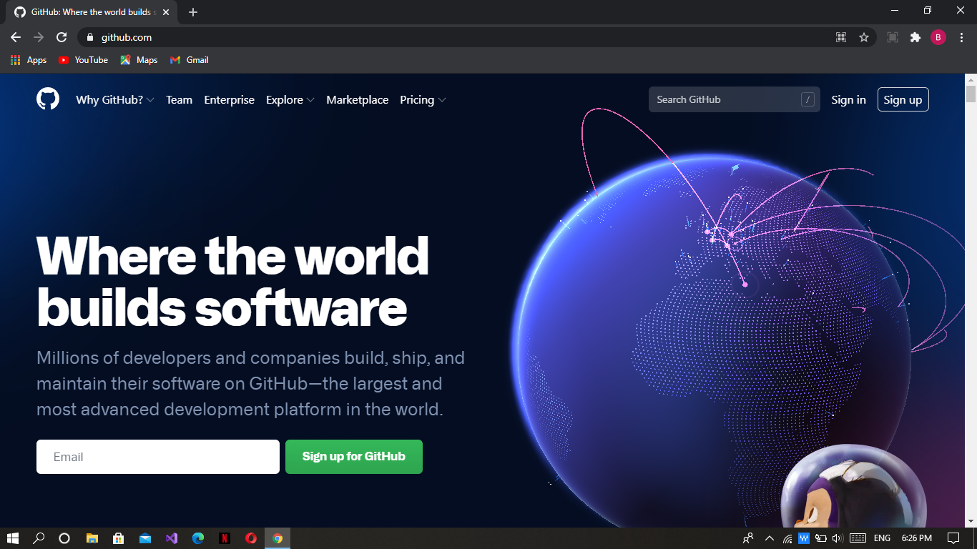

1. Make a new repository.

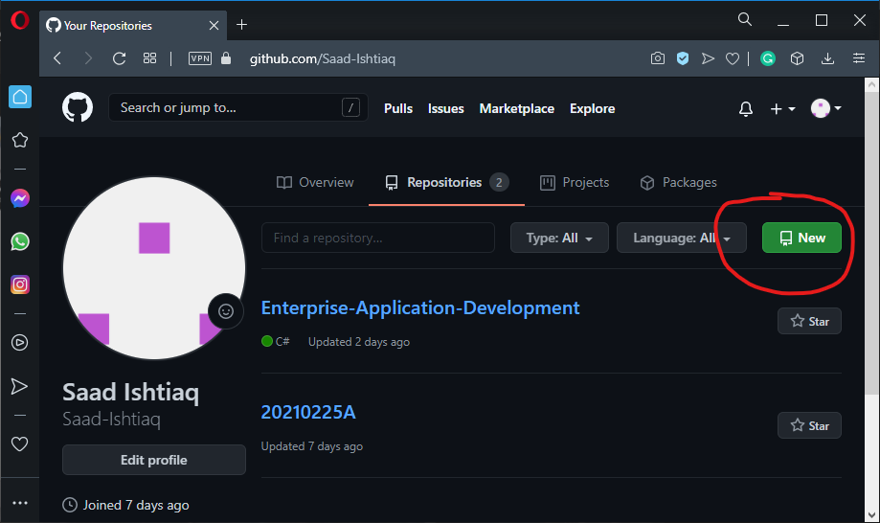

1. Give it a meaningful name. I am giving “MC_Progress”.

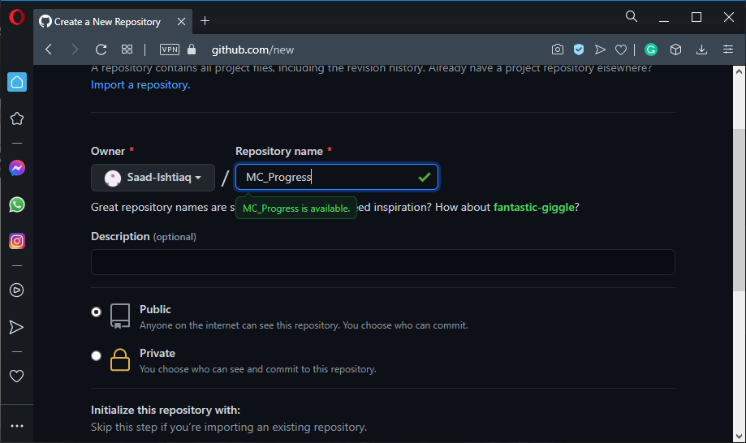

(Keep it public so that other people may get benefit.)

After configuring press “create repository” button.

1. Copy repository link. We need it in coming steps.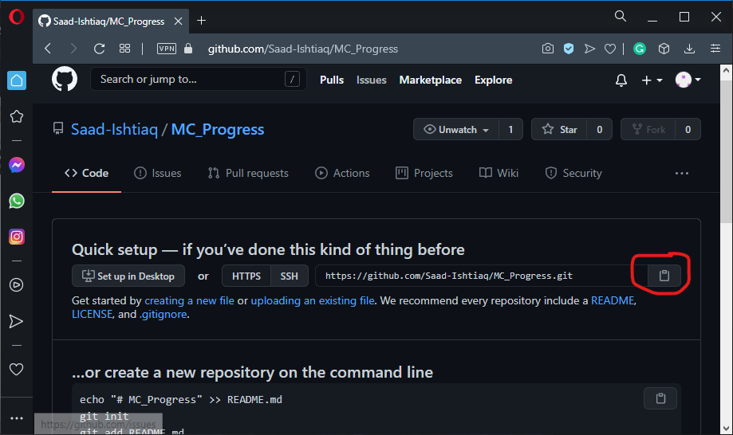
2. You must install git in you machine. Type “git install” on google. Download and install it.

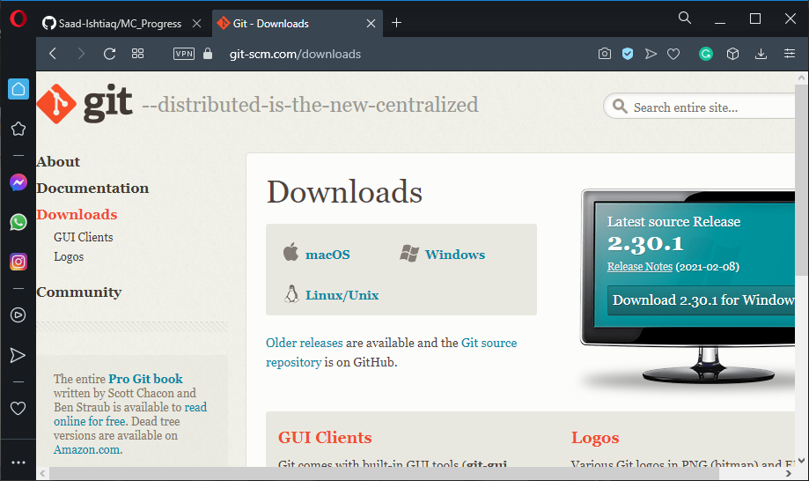

1. Now make a folder named as git.

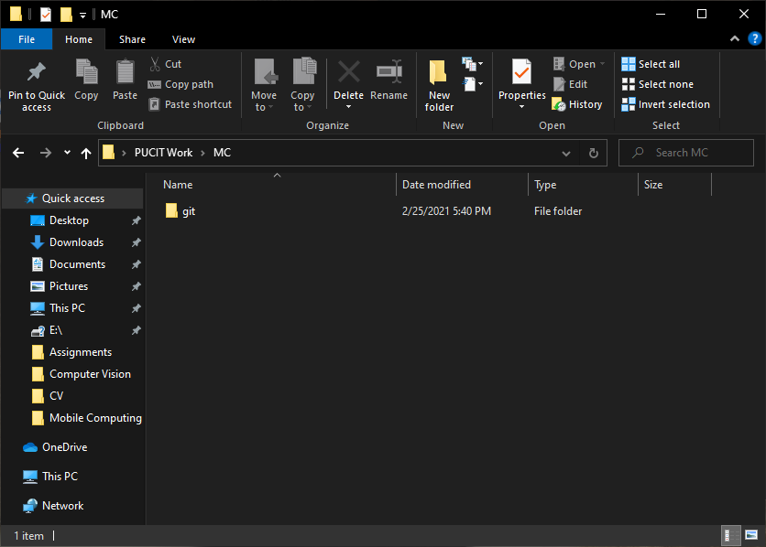

1. Now open cmd (run as administator)

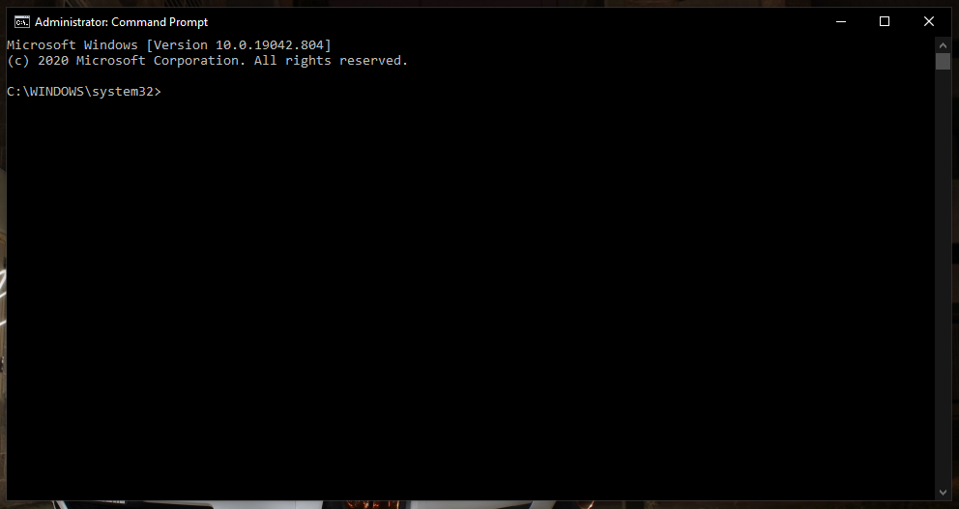

1. Use cd command and go to desired directory.

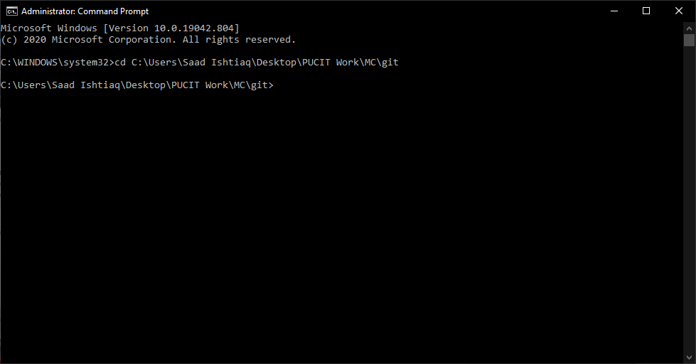

1. Write “git clone [parameter i.e url]”. Paste the link in place of parameter you previously coppied.

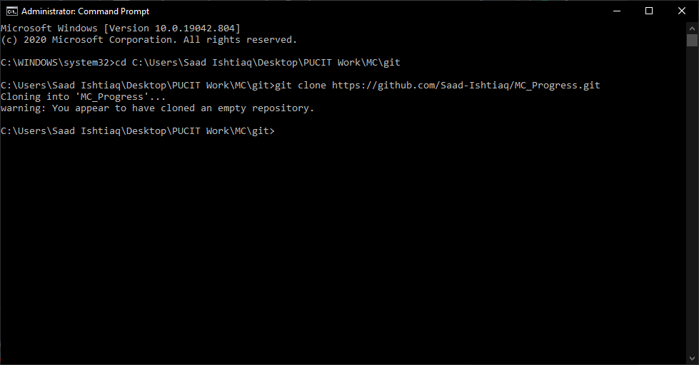

We have cloned the repository. Don,t bother about the warning message. It is just telling us that we have cloned an empty repository.

1. You will observe a folder automatically got created with the name of the repository.

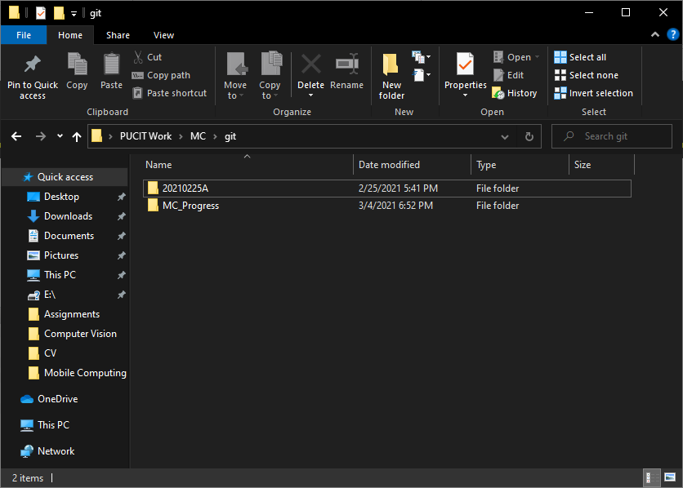

1. Lets make a .txt file to understand its communication with repository. Go to folder MC_Progress using cd. Write “git add [filename.ext]”. 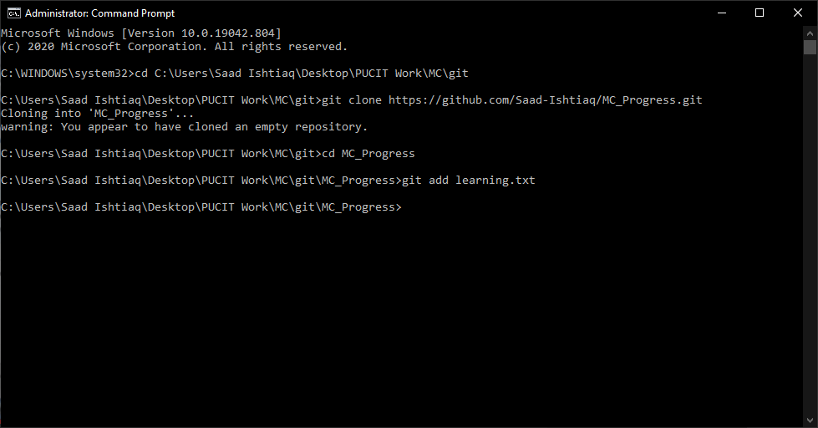

(you maybe asked to login your github id and password when use git command first time. Its is not an error just copy the commands given by cmd and paste it by changing your credentials)

1. Now type “git commit -m “Message” ”.

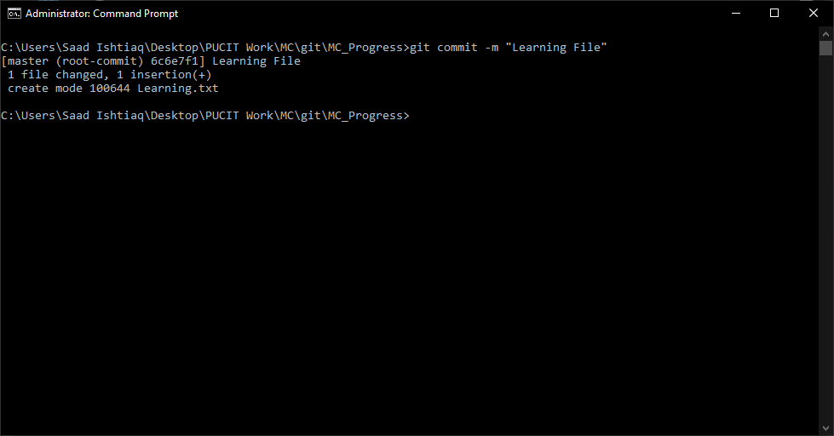

1. Now push the file to the repository by typing “git push”.

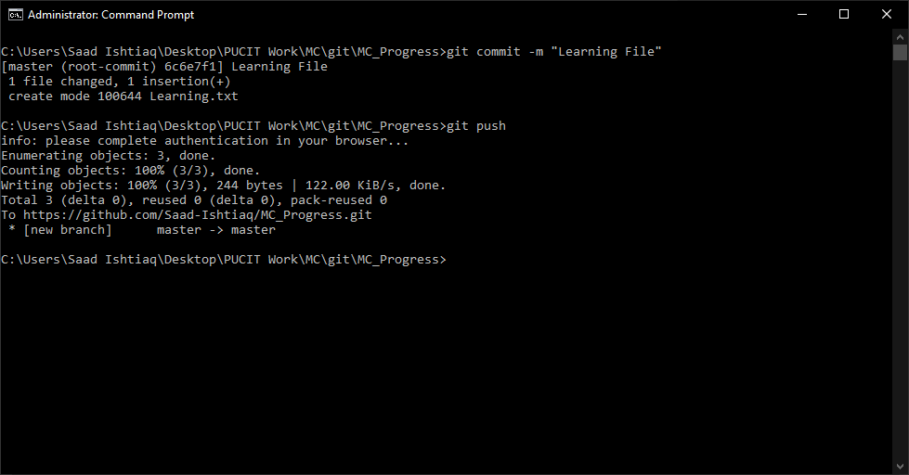

Now you can see the file in online repository.

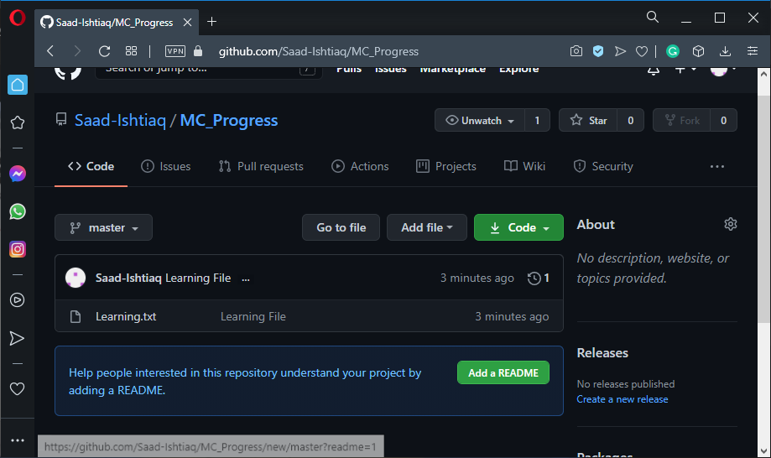

1. Today almost every IDE supports github and tells that we have made changed to the file. Lets open the file in VS code. When we write a line message pops. It also tells all the versions of our file.

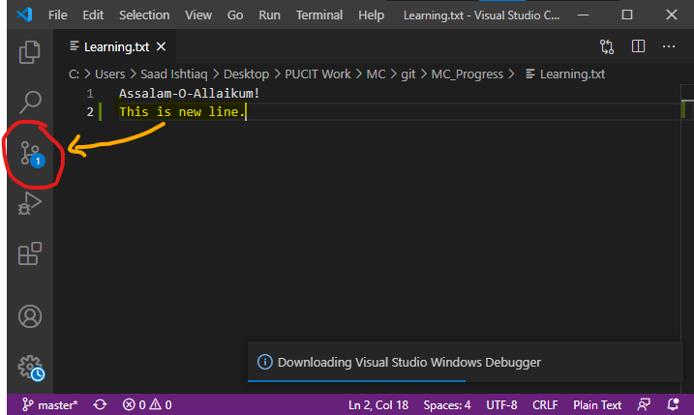

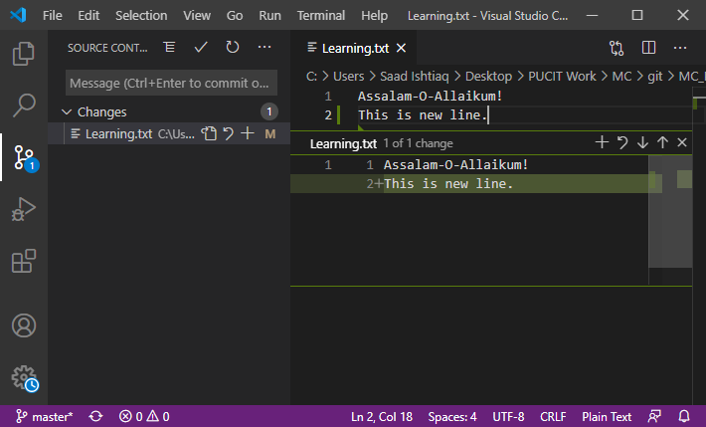

1. Moreover when we push the updated file by repeating same steps.We may see parent (previous versions) of our file

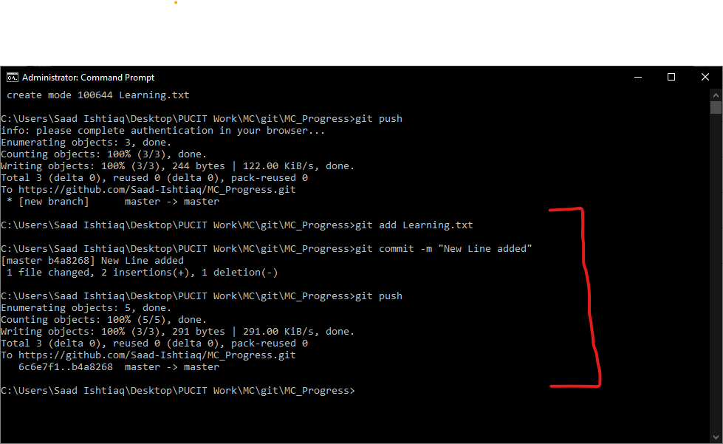

Repeating the steps to upload updated version

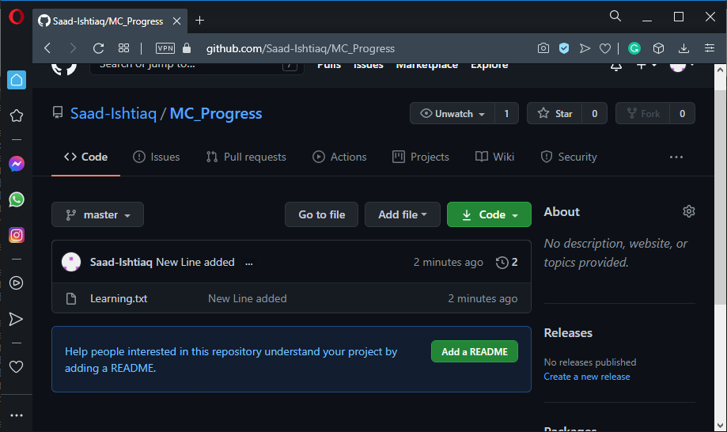

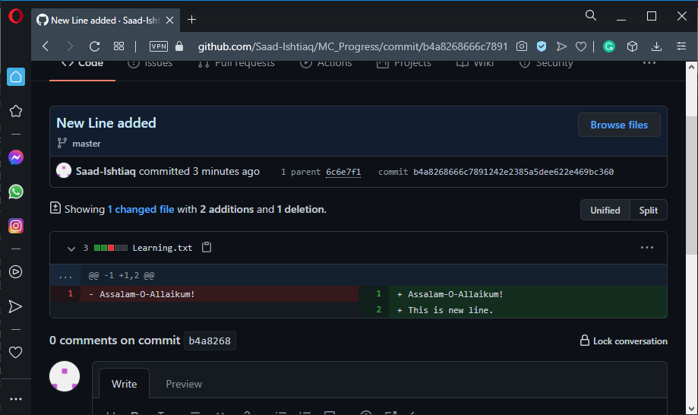

*******************Now have a break. Go and have some refreshments*********************

******************************** Let this knowledge sink in *************************************

**(Wellcome Back!)**

We will start our practice by editing our file.

1. Click on the pen like icon and modify your files as required. Scroll down and click “commit changes” button.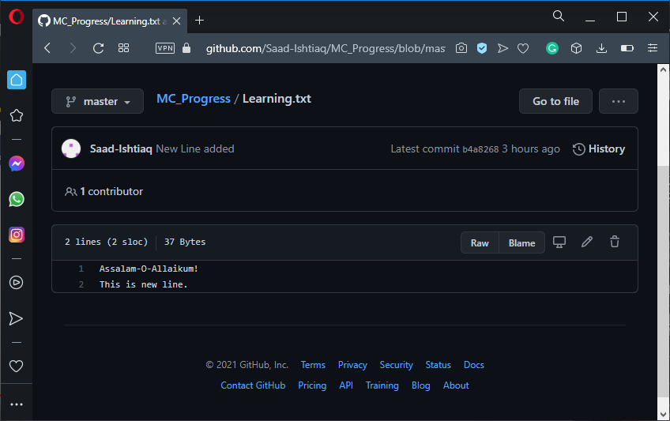

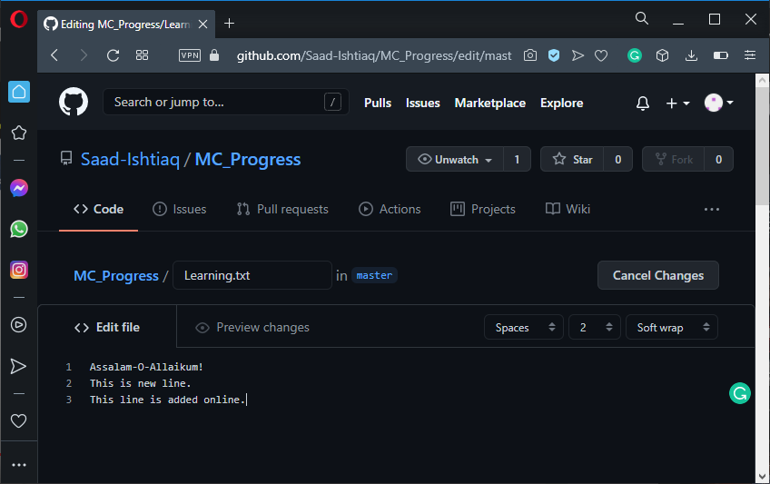

1. Now we will use “git pull” command. It is used when we want to synchronize data i.e take data from online repository to our local machine.

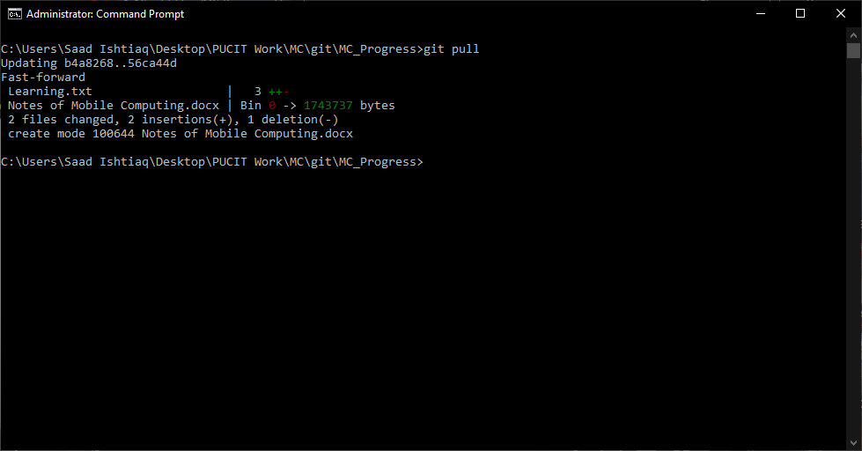

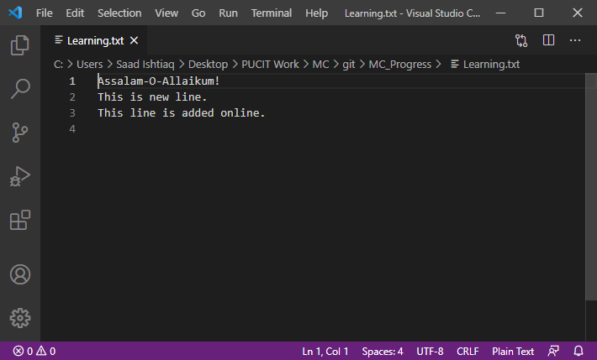

**Merge Conflicts**

It is very important concept. It arises when same line of code is being changed by two users. We will understand it by experimentation.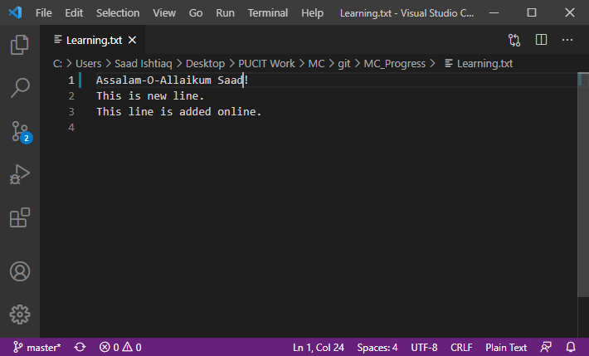 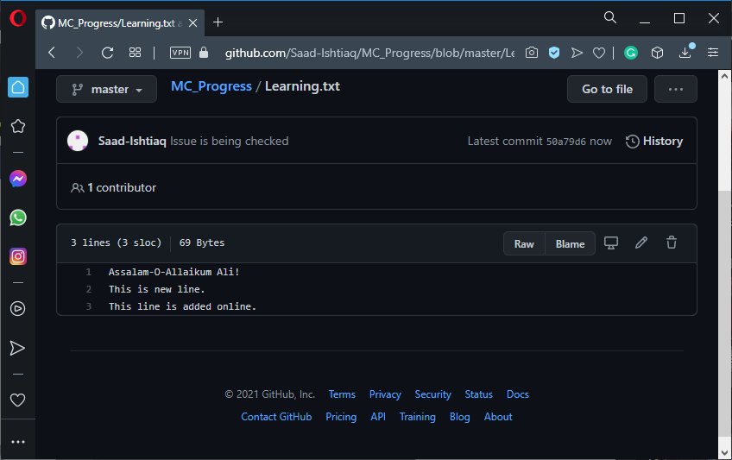

We got error so we resolved our merge issue in VS code and re pushed the file.

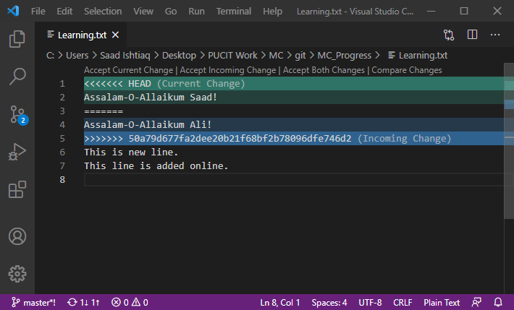

( git commit -am “Issue Resolved” is used to add and commit at the same time.)

1. git log is used to view details of commit

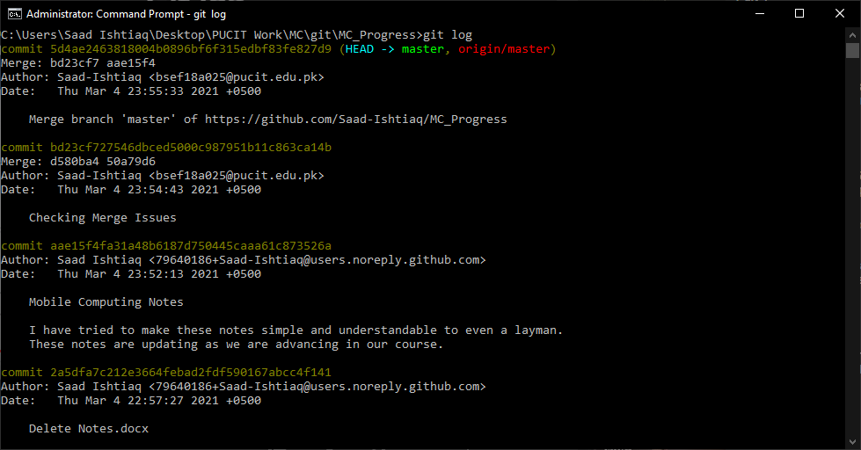

To learn New Concepts, make two new files and push them.

I named them as File2 and File3.

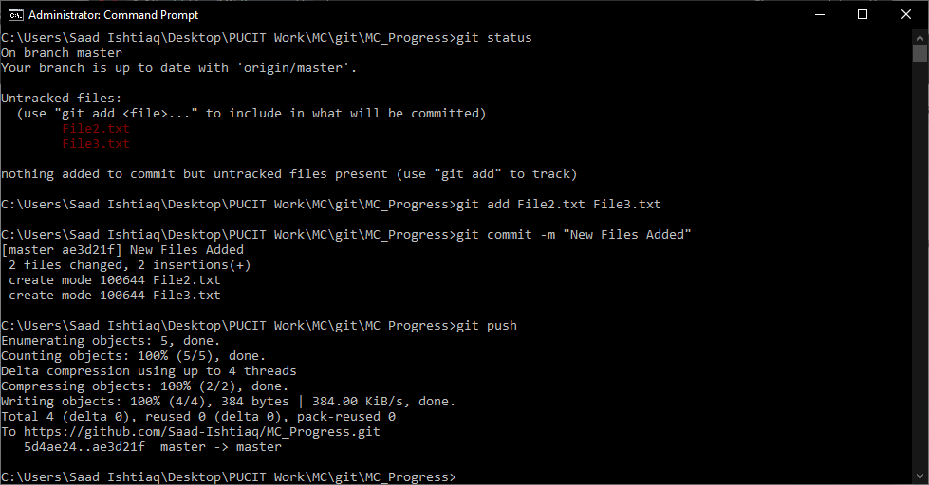

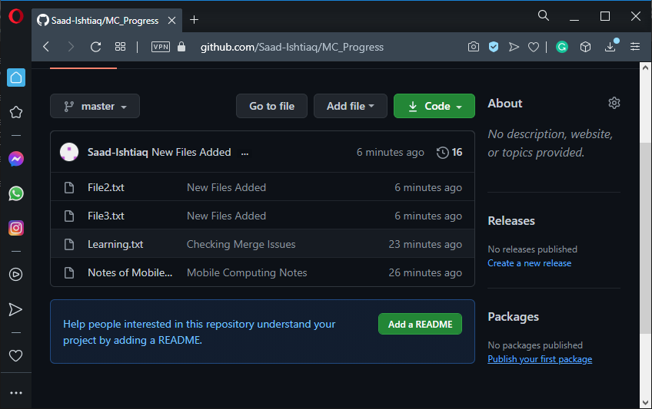

1. To delete a file, use “git rm filename.ext”

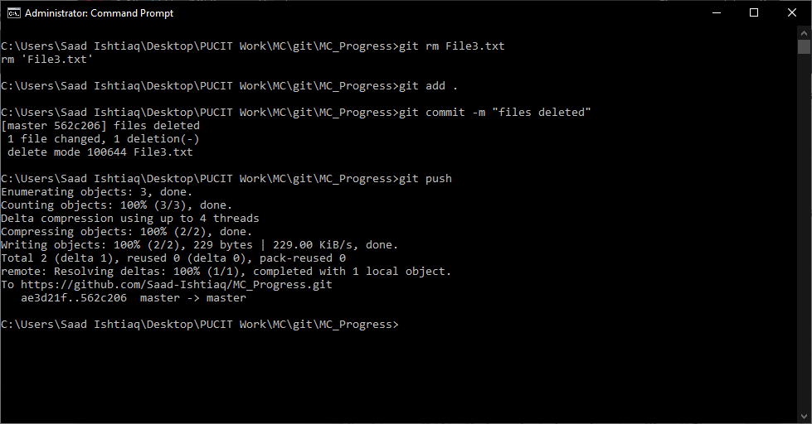

“git add .” is used to add all files.

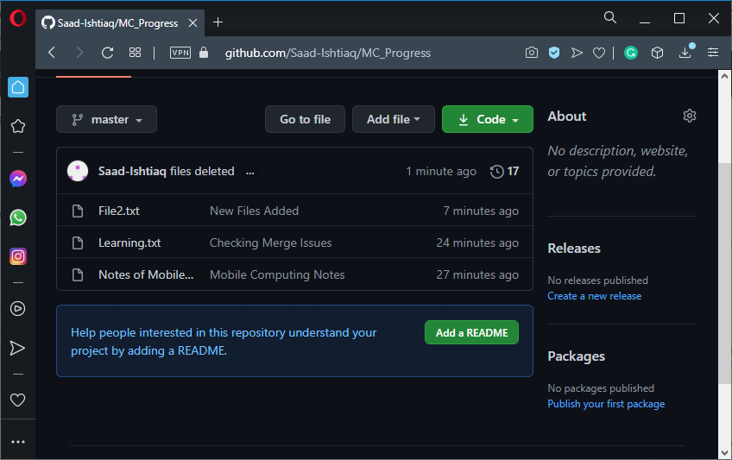

**Concept of Branching**

Let us assume we have a version. And we carry on working on differentflows. Ultimately we want to merge them. Branches help us to work on various features of same file.

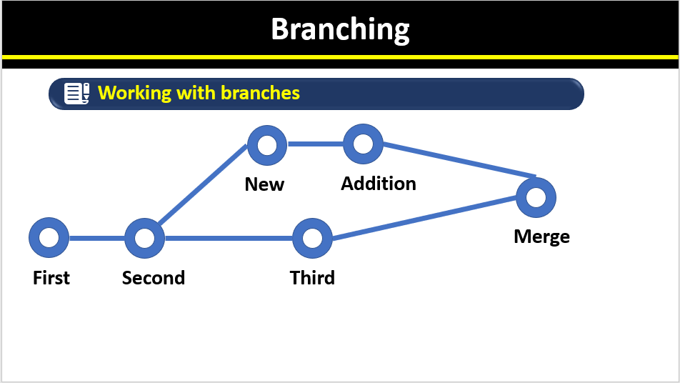

* Branch
* Merge
* Checkout

1. git branch

To check all branches branch. (* shows current branch)

1. git checkout

To create branch and after creation it opens new branch.

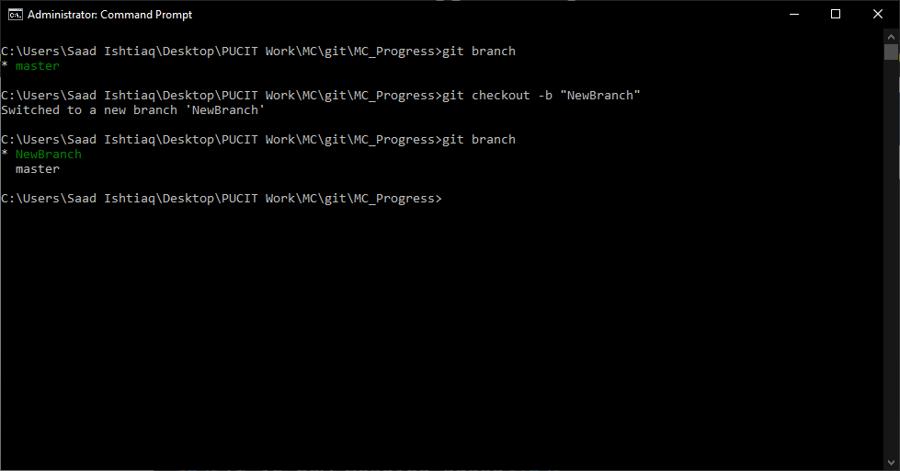

Here we made a branch and then write something on it, saved it and commited it. Then changed branch to master and ide shows us the previous version i.e unchanged one.

NewBranch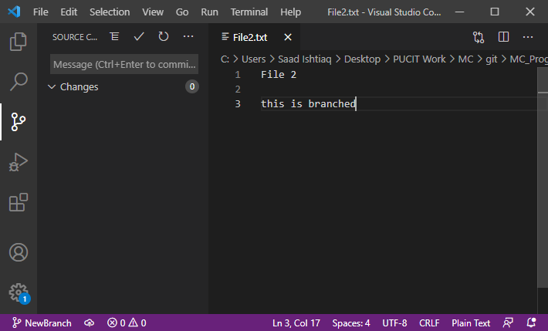

Cmd : creating new, saving and commiting (+ shifting to master) 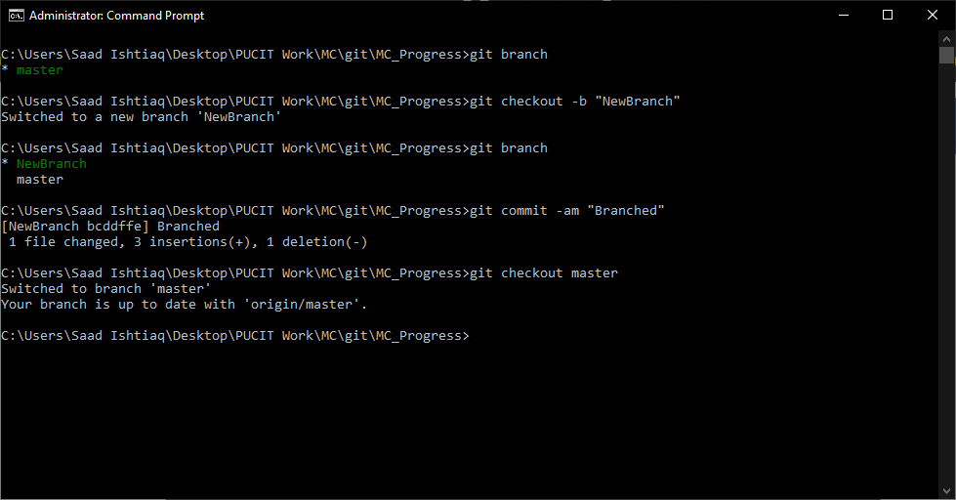

Ide Changing into previous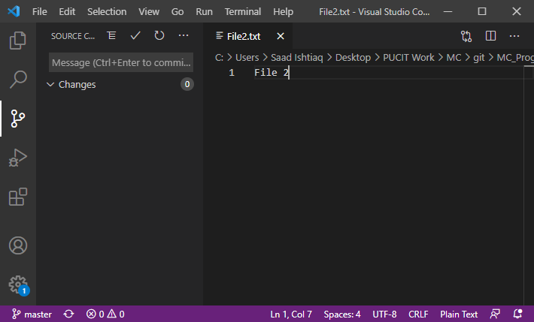

1. git merge [NewBranch]

Look at following picture se Simply checked master branch and then merged them. And the deleted new branch by

“git branch -D NewBranch”

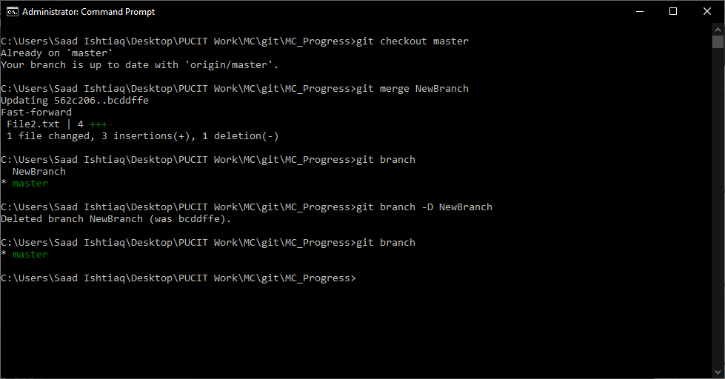

Use checkout to go to master branch

******************* Have a break. Go and spend some time with family ********************

***************************** Topic VCS is completed here ********************************

ٱلْحَمْدُ لِلَّٰهِ‎

**Android Studio**

Install and setup android studio. Make an empty project project. A “Hello World” mobile application will be made by defualt. Following is screenshots of android app I tried to make with very basic knowledge just to set up the pace and become familiar with the interface.

**ScreenShots:**

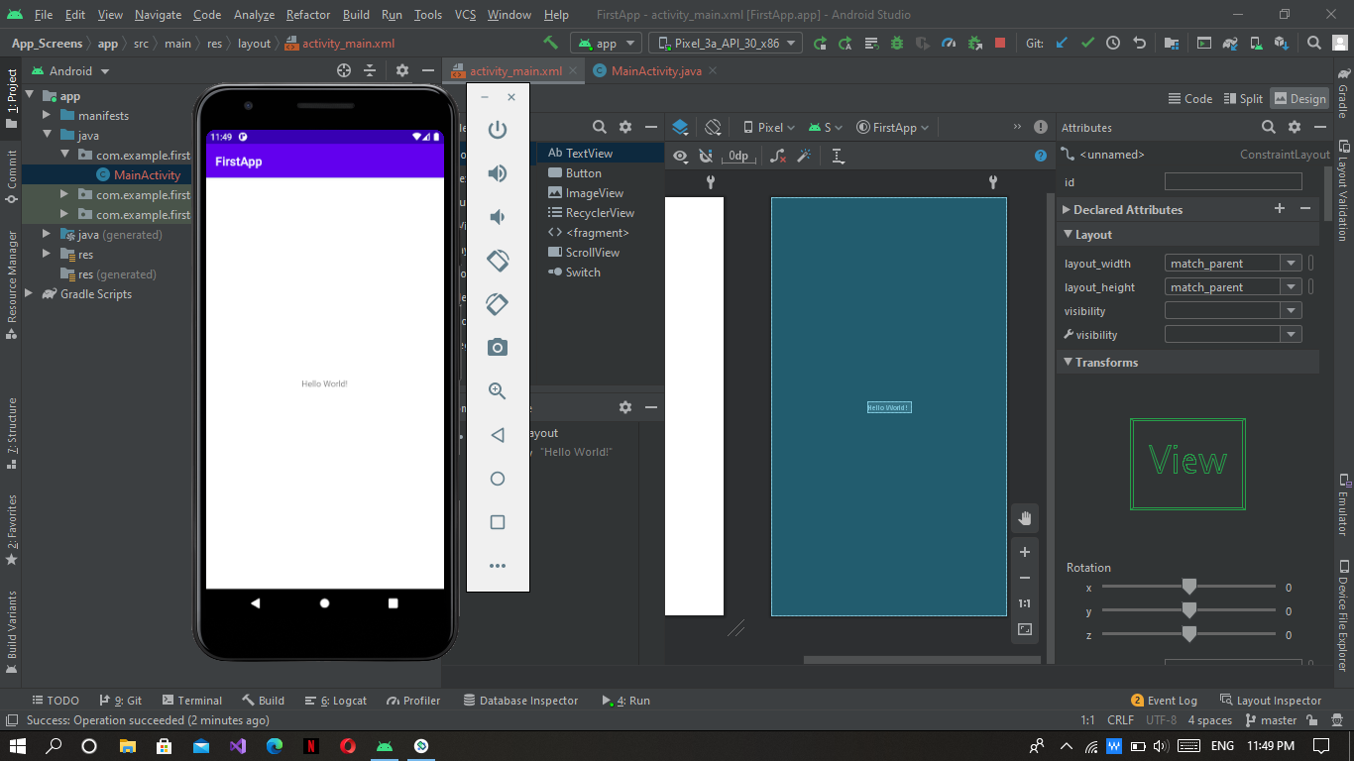

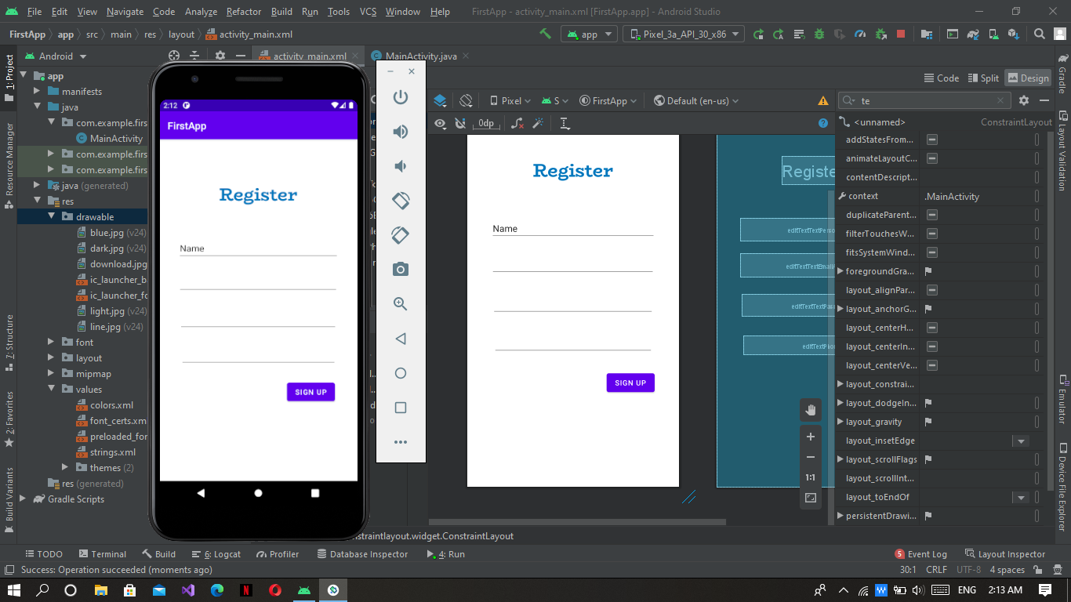

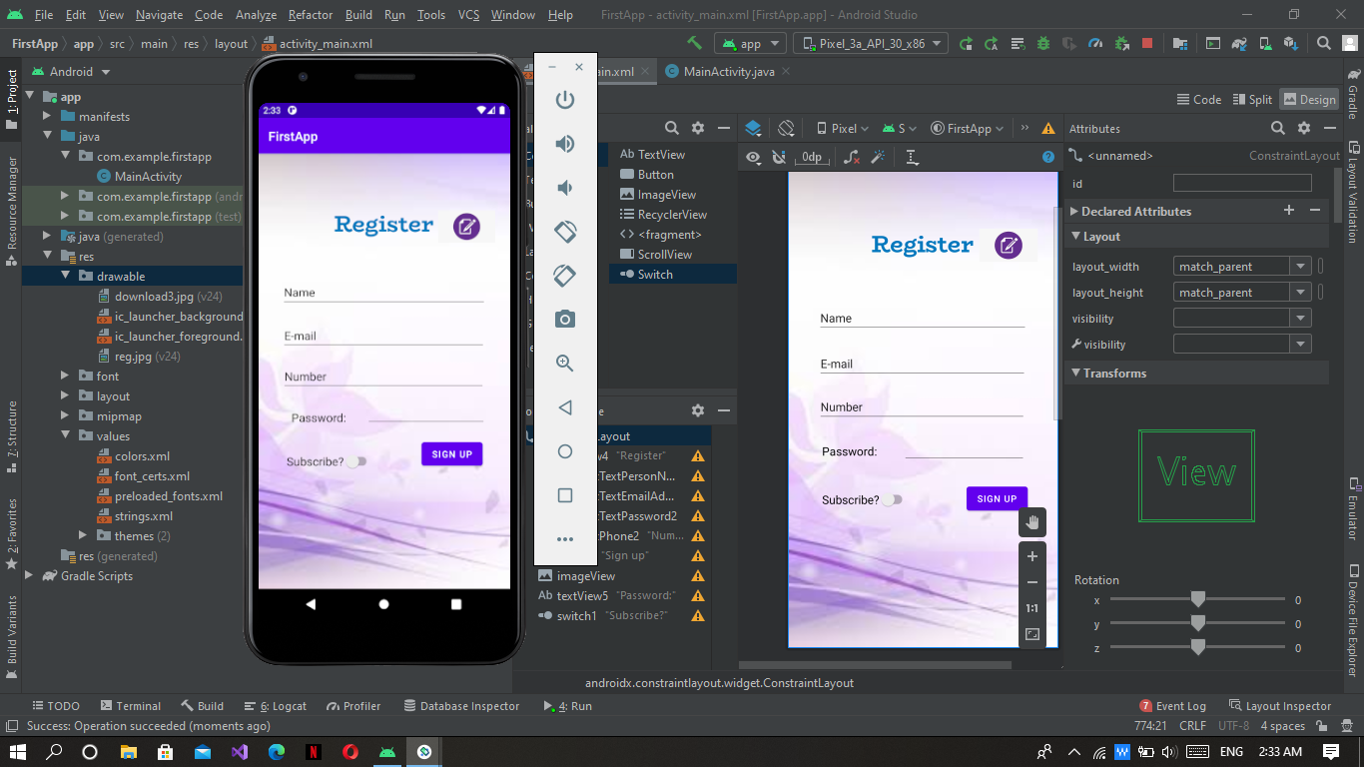

**Intent**

An [Intent](https://developer.android.com/reference/android/content/Intent) is a messaging object you can use to request an action from another [app component](https://developer.android.com/guide/components/fundamentals#Components).

There are two types of intents:

* **Explicit intents** specify which application will satisfy the intent, by supplying either the target app's package name or a fully-qualified component class name. You'll typically use an explicit intent to start a component in your own app, because you know the class name of the activity or service you want to start. For example, you might start a new activity within your app in response to a user action, or start a service to download a file in the background.
* **Implicit intents** do not name a specific component, but instead declare a general action to perform, which allows a component from another app to handle it. For example, if you want to show the user a location on a map, you can use an implicit intent to request that another capable app show a specified location on a map.

**Following Screenshot shows the coding of both Intents:**

Impilicit Intent:

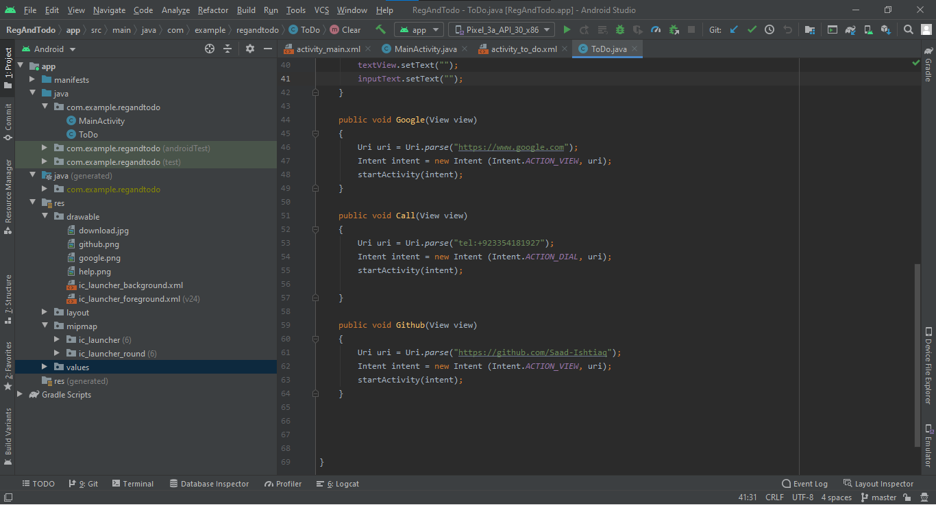

In Picture Above I have made Functions(methods) which acts with onClick function.

Google, Call and Github funtions are examples how we can make implicit intents.

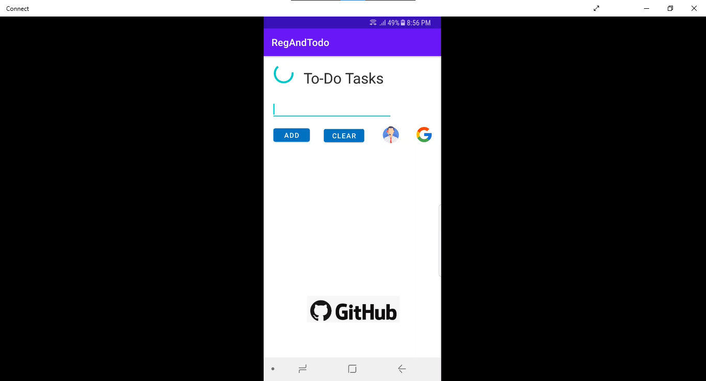

Look at picture below When I touch Google Icon it asks me which App do I want to use to perform the action.

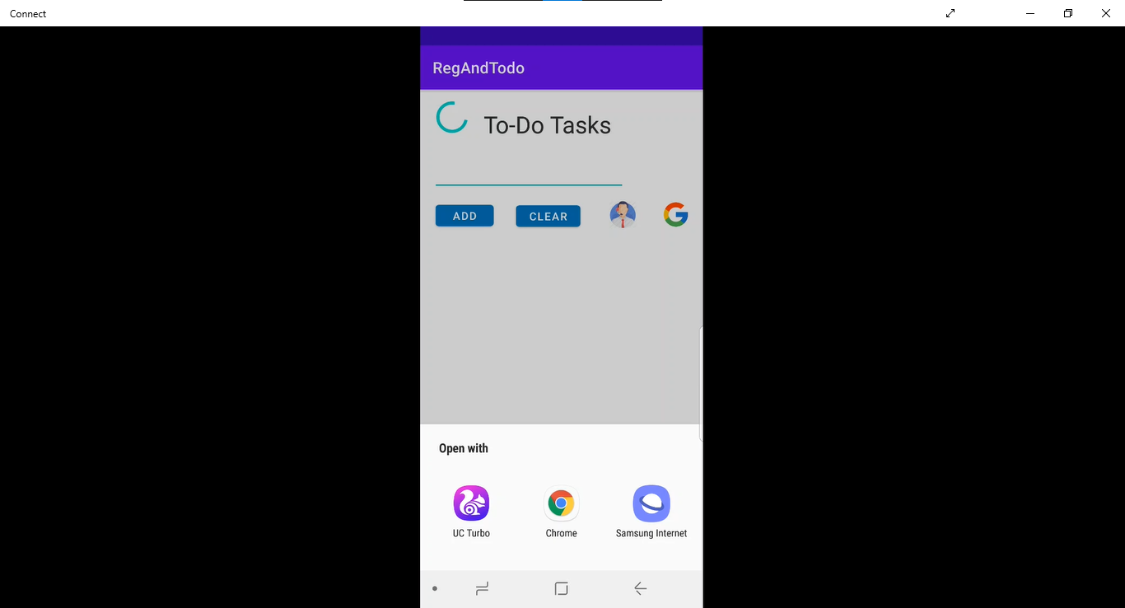

Explicit Intent:

Similar as Above onClick of ”Sign Up” button explicit intent will be called.

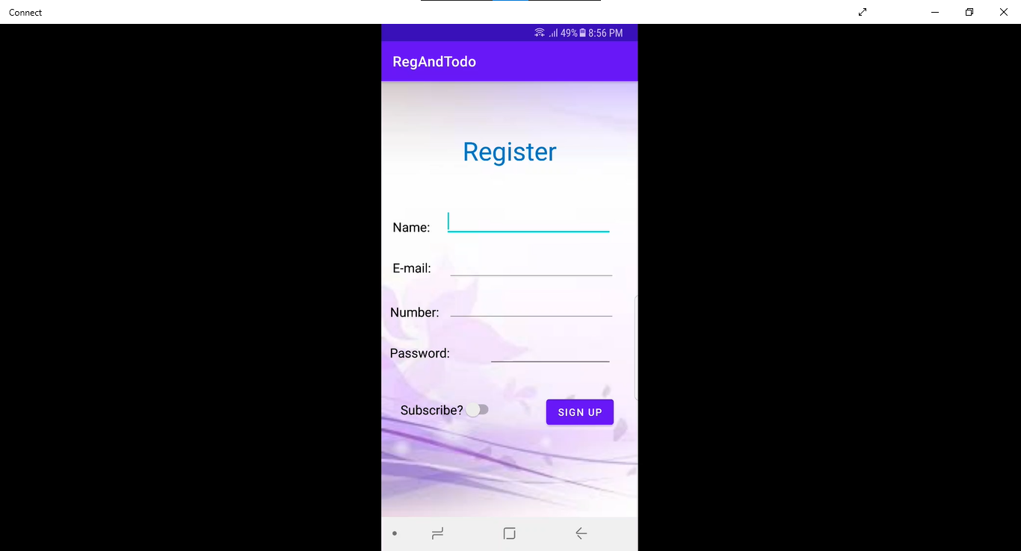

Here is its coding.Here We made a new Empty Activity and then gave its link in the Intent.

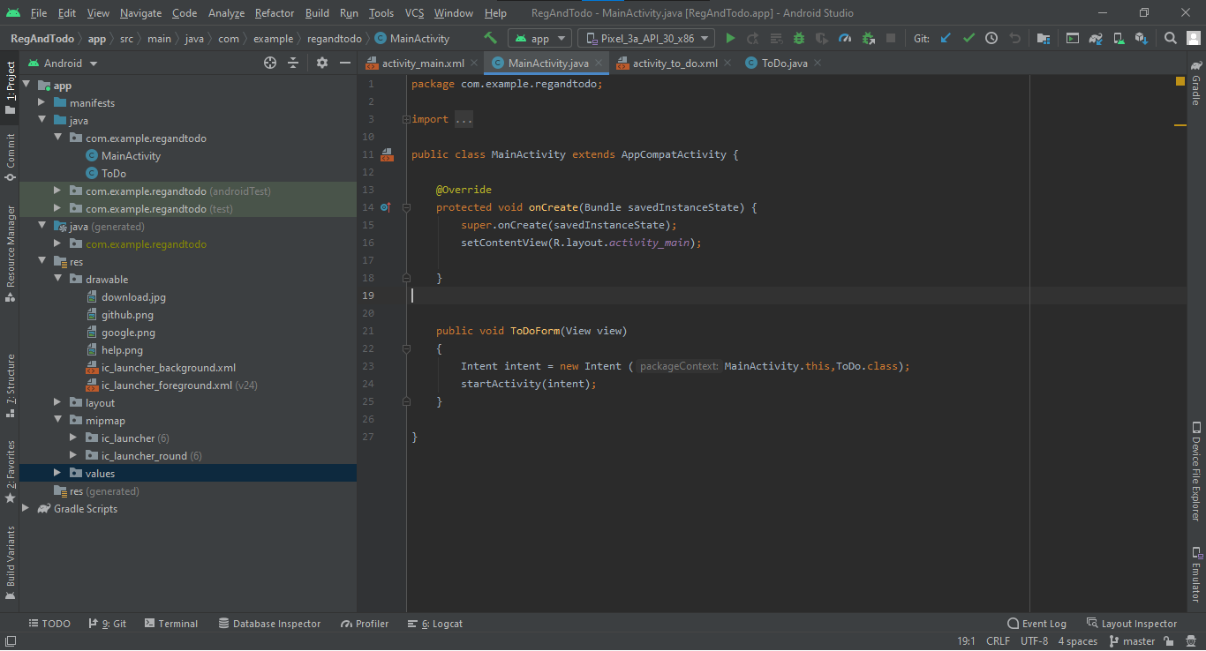

Project: <https://github.com/Saad-Ishtiaq/MC-Work/tree/master/RegAndTodo>

**Activity Life-Cycle**

We found a issue if we make a counter and then change aur screen to potrait to landscape mode or vice versa. To solve this we saved the state of values before they stop or pause then reuse them after action is resumed or starts. See following code.

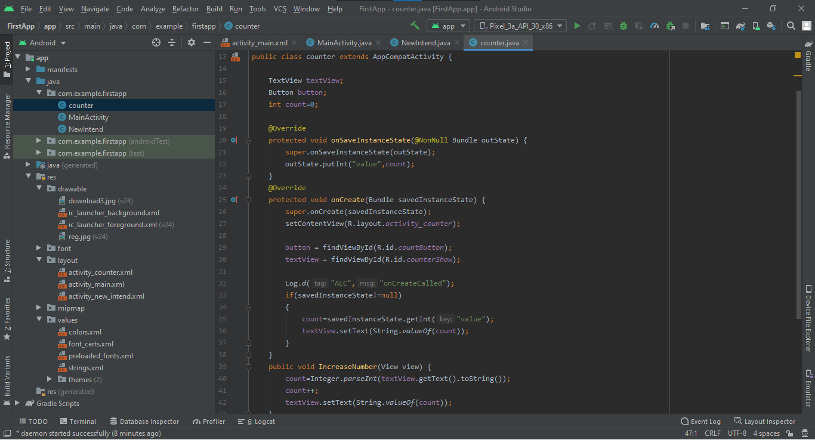

To understand life cycle of an activity try this piece of code.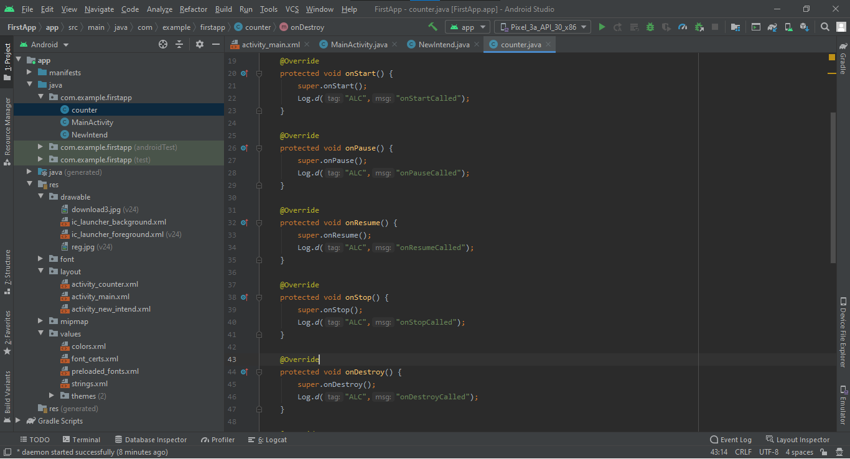

**Animation**

To Add Audio/Video just add audio/video to the resources and then write code as shown in the image below.

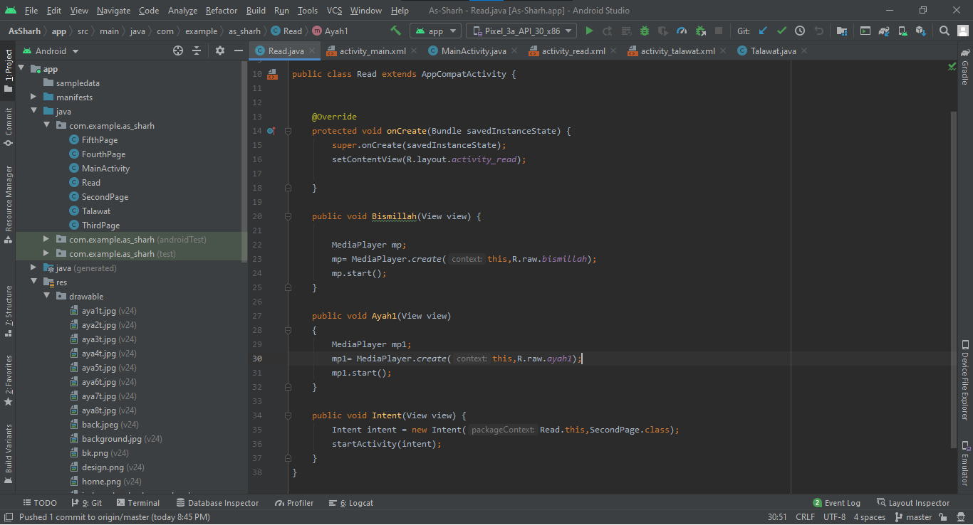

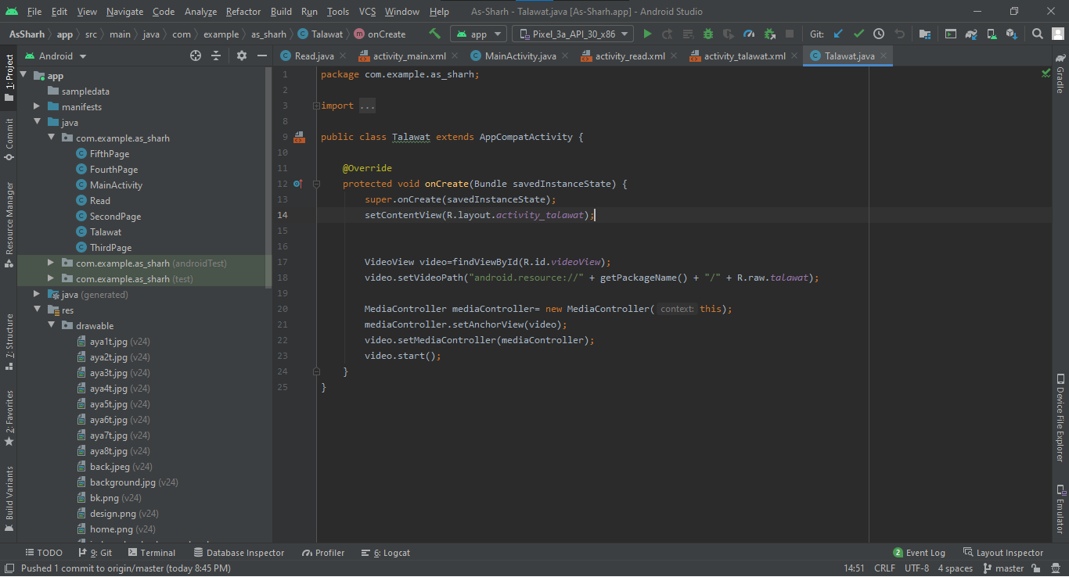

This Block Add media controller to video

You can See the project at “<https://github.com/Saad-Ishtiaq/As-Sharh>”.

**Arrays**

To show array of text we use “ArrayList” and “ArrayAdapter<datatype>”

Follow following steps:

1. Add a ListView Object on screen
2. Make an Array and fill it with string
3. Make ArrayAdapter object and set it values as given below
4. setAdapter and You are good to go!!!

You may view which Item of array is being clicked by user. Its code is given in red Box do check it out.

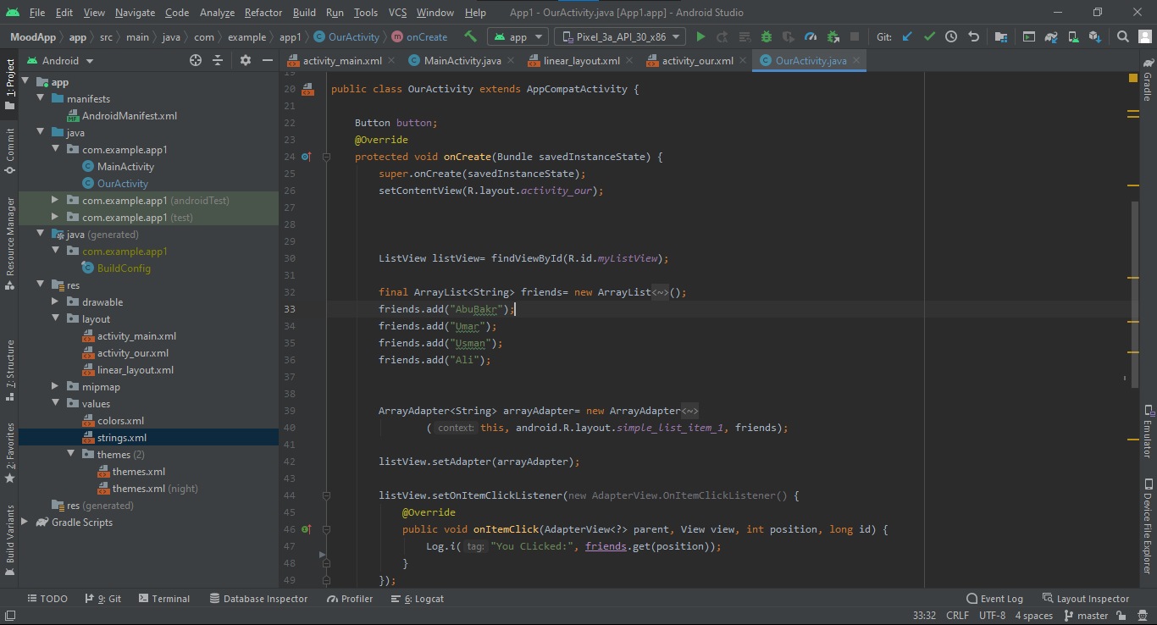

To Add an Array onClick of a button:

Steps:

1. Make an inputbox
2. Make a button
3. Get text from inputbox
4. Add text into the array you made earlier
5. Notify data set is changed to the array adapter by calling arrayAdapter.notifyDataSetChanged();

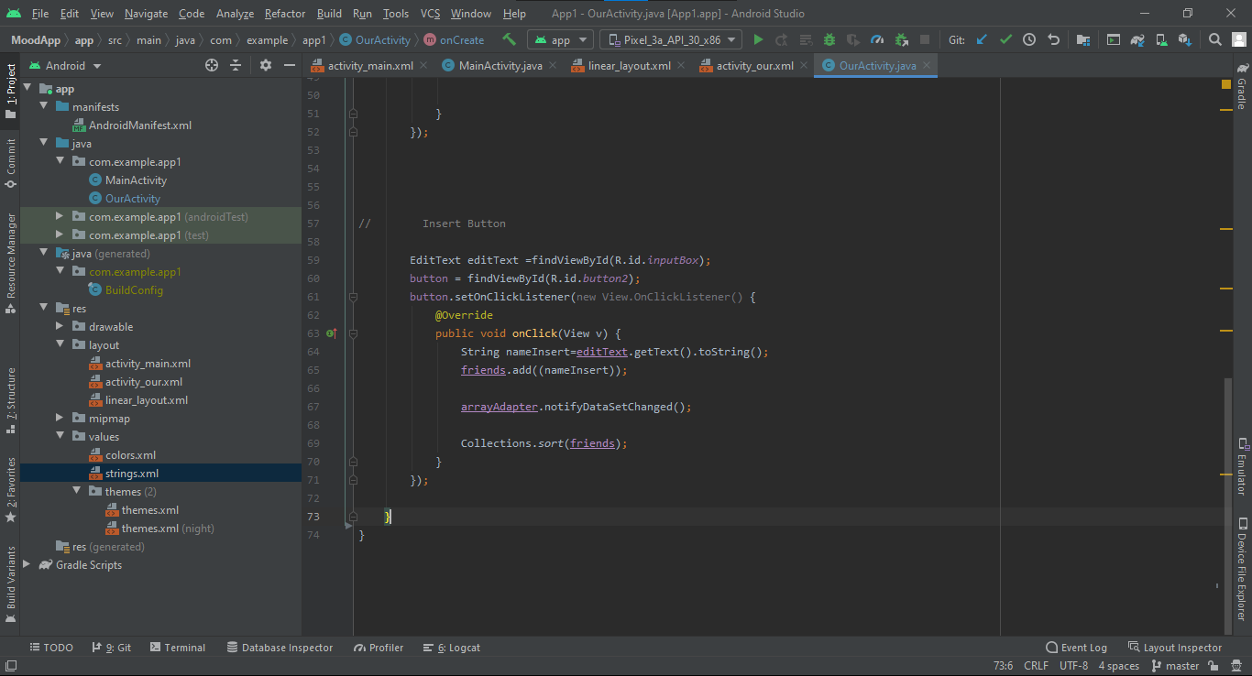

You can See the project at:

<https://github.com/Saad-Ishtiaq/MC-Work/tree/master/MoodApp>

**Sql Lite**

We made an interface in which we have two input text boxes, one for name and second for age and one switch which tells either the user is active or not, two buttons (add record and view record) and delete button and delete input box. Shown in figure below:

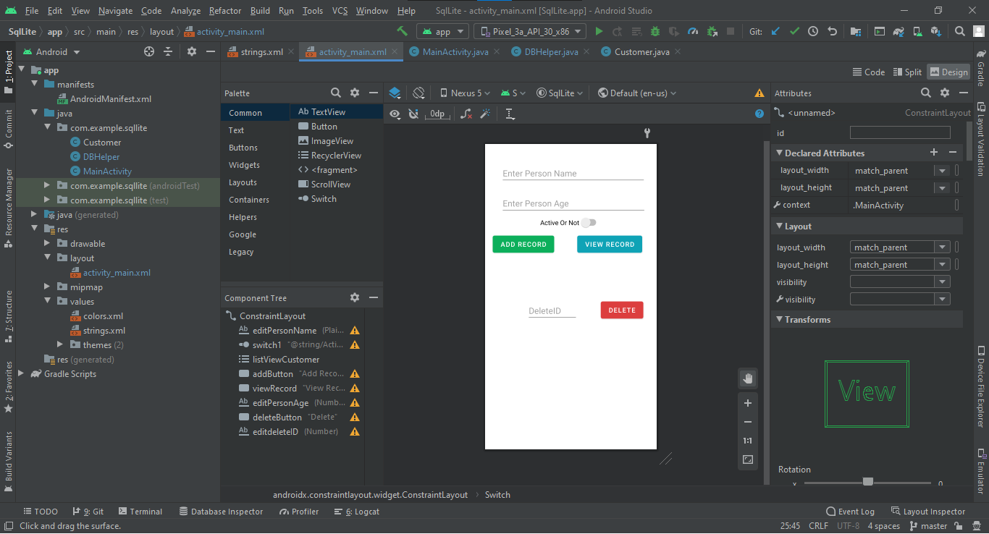

We want to store data we enter in a database so we will make a Customer class in our application

It has variables, name ,age , isActive and id.

We used system function “Generate” to make getters and setters of all the variables, We also made constructor for the class. All these coding is displayed in picture below. Please do refer to it.

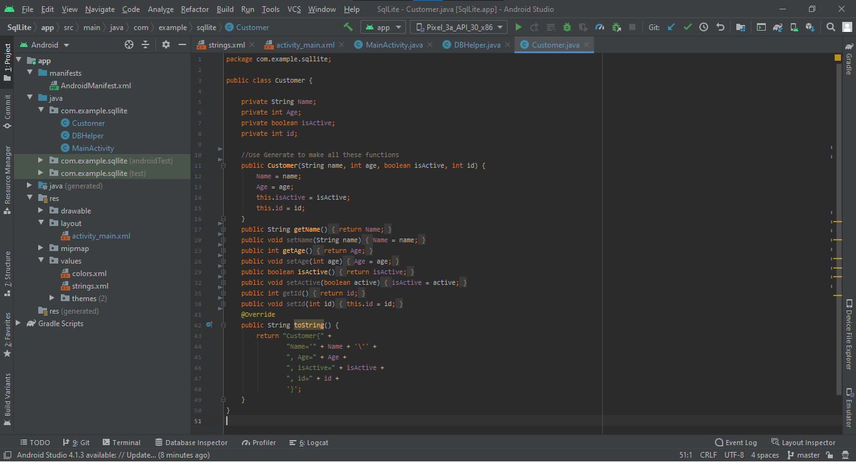

Create a DBHelper class which will have functions which add and delete out data into database. Implementation is shown in images below.

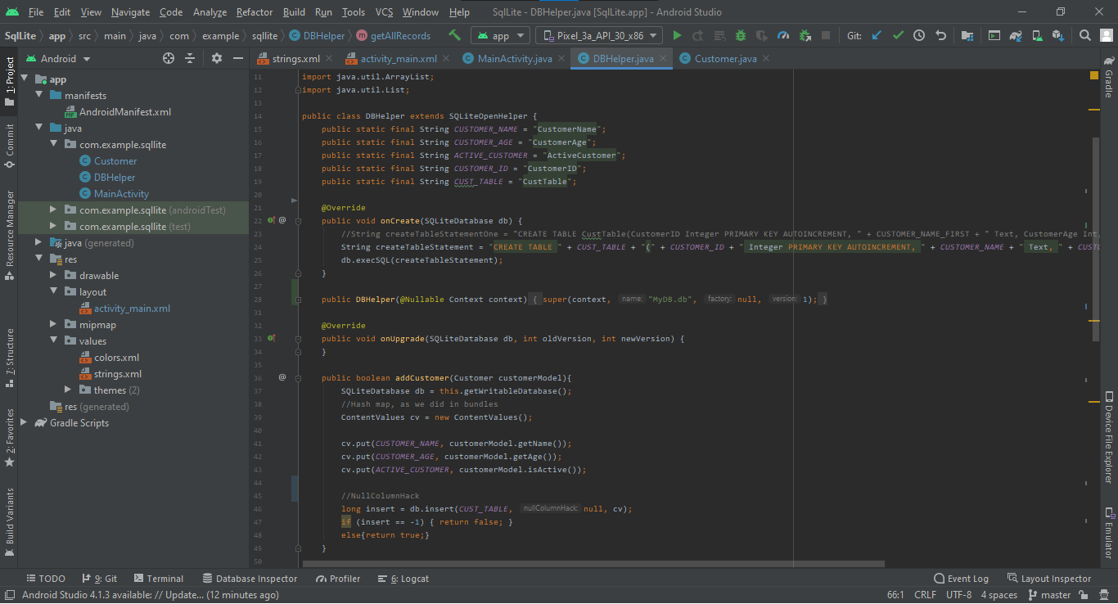

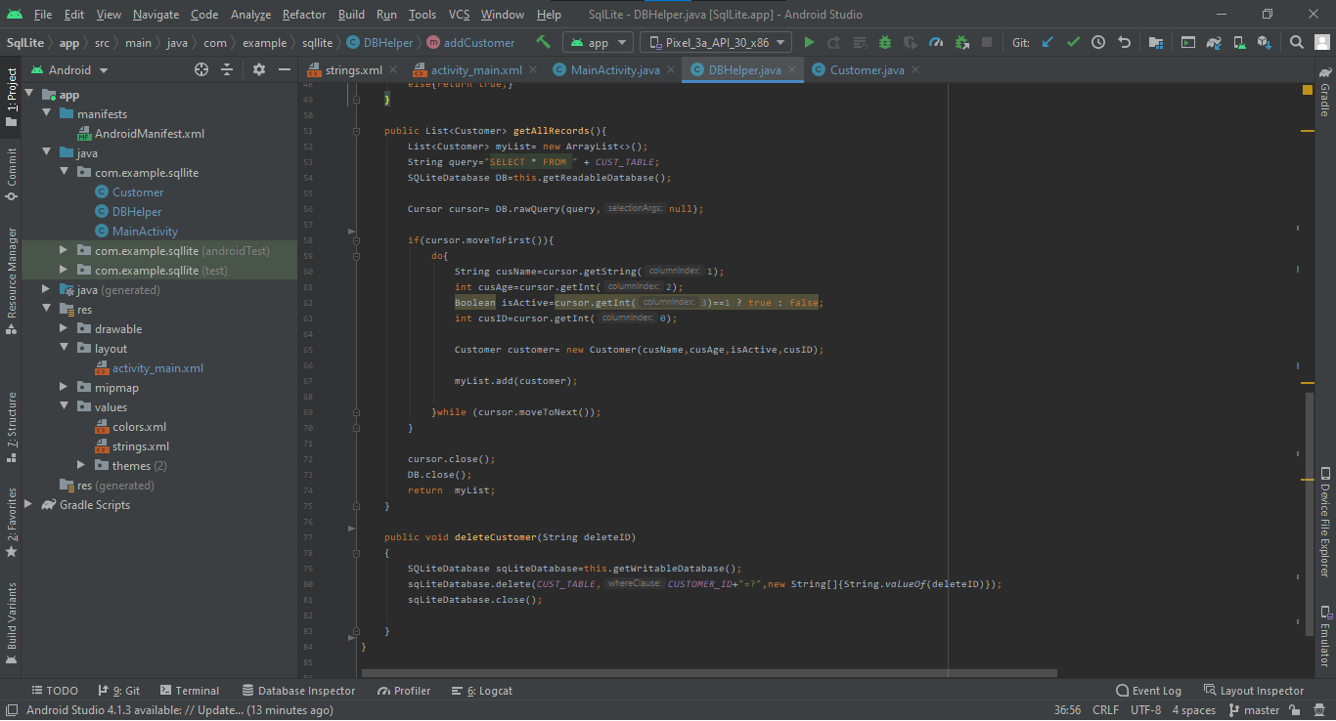

We will use these functions in our MainActivity to make our app complete.

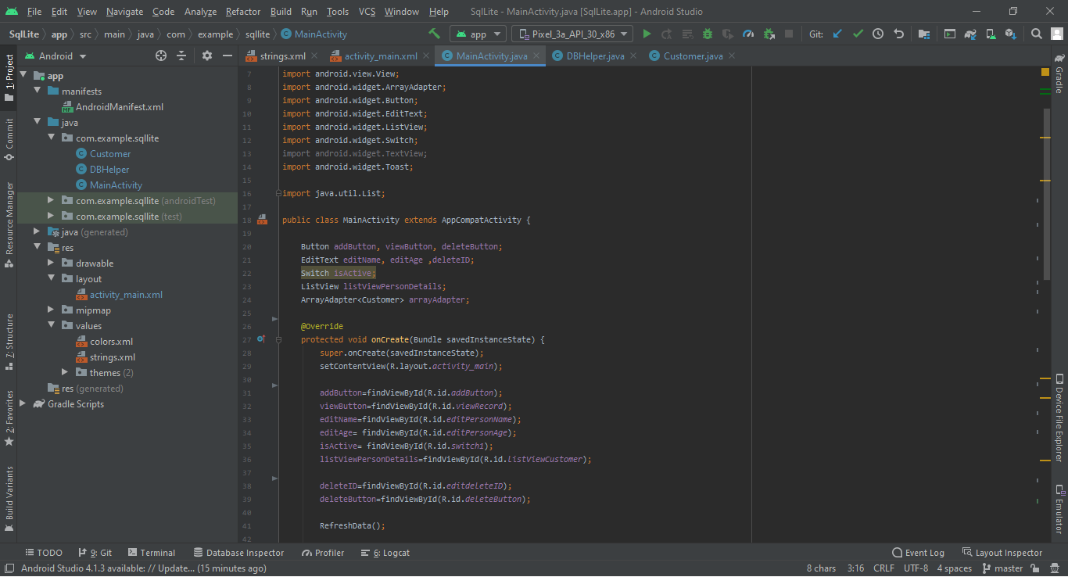

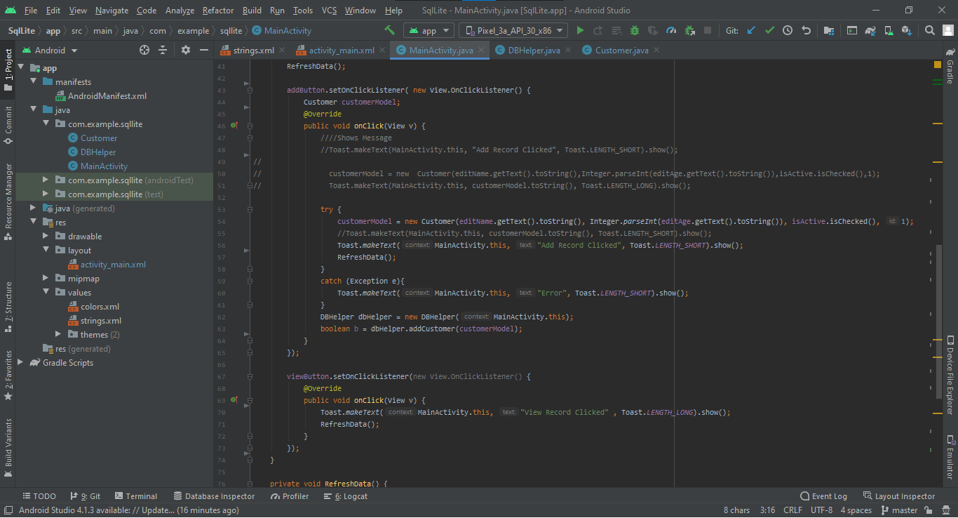 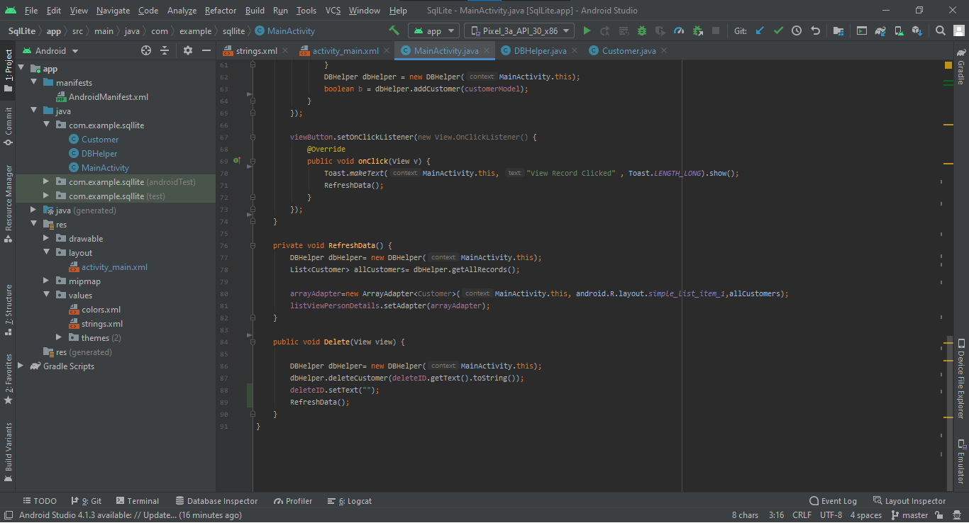

Click the link to view the code:

<https://github.com/Saad-Ishtiaq/MC-Work/tree/master/SqlLite>

**Navigation Bar**

It is common practice of programmers to add navigation bar to navigate between different actions in an app. We are going to add a navigation bar to our apps.

Firstly, add dependencies in build.gradle.

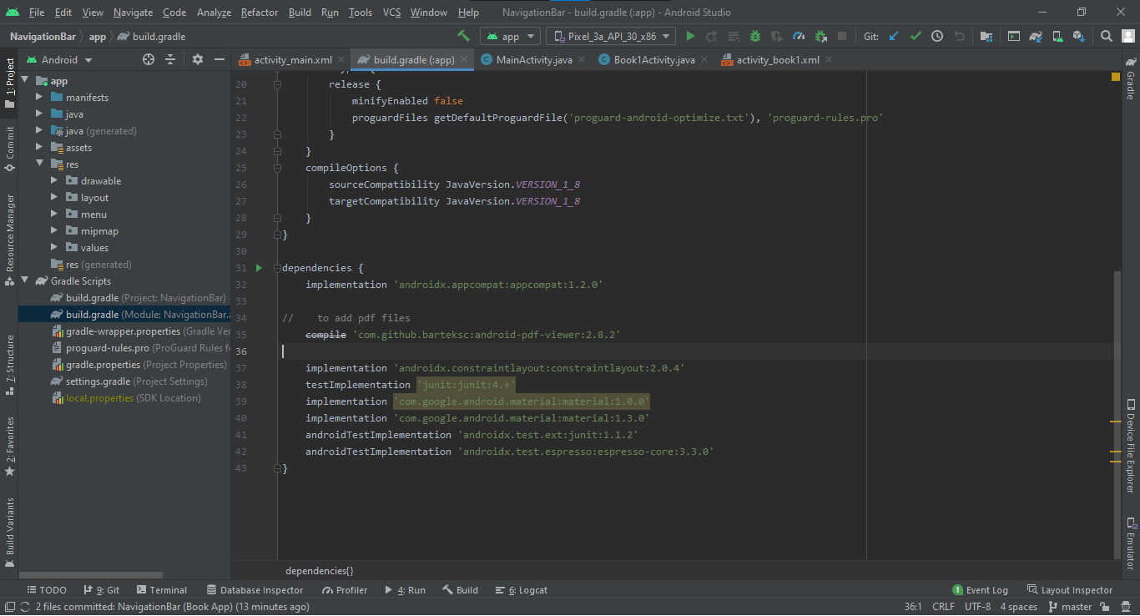

Make a new directory and add menu.xml in it. Also add header.xml in layout folder, These combined make the navigator bar.

**Menu.xml:**

Code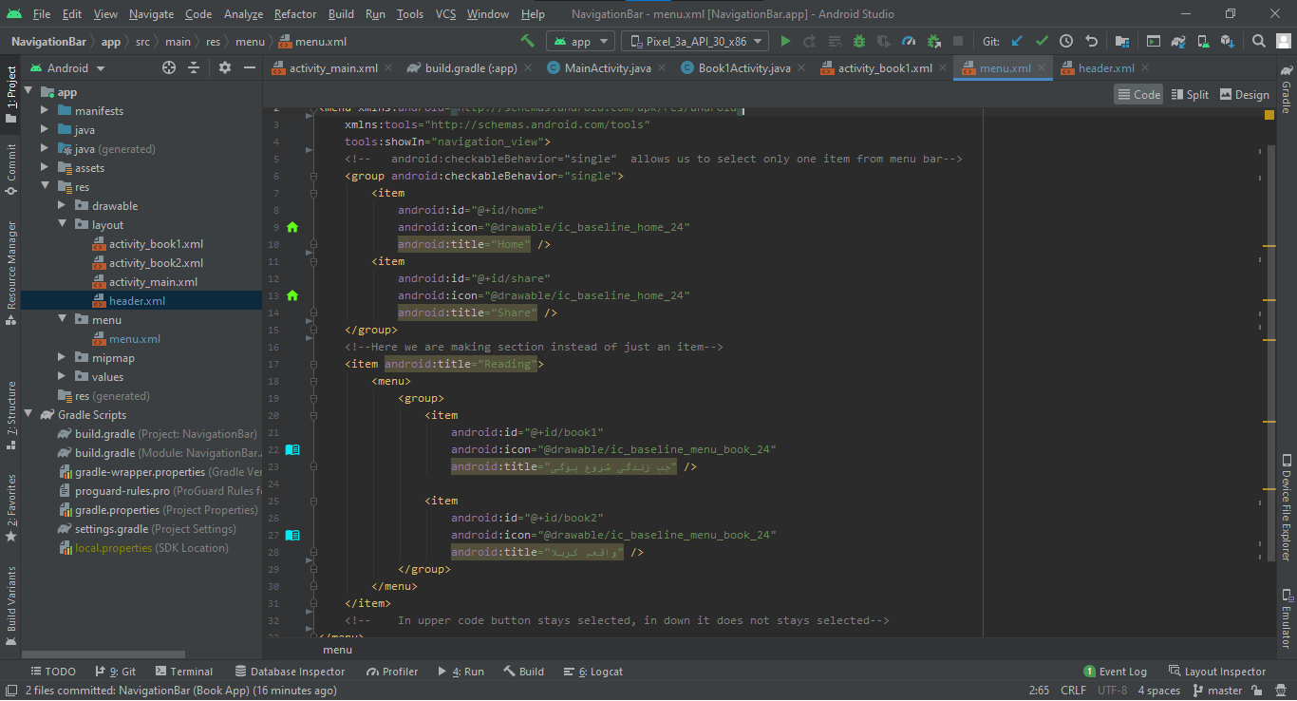

Design

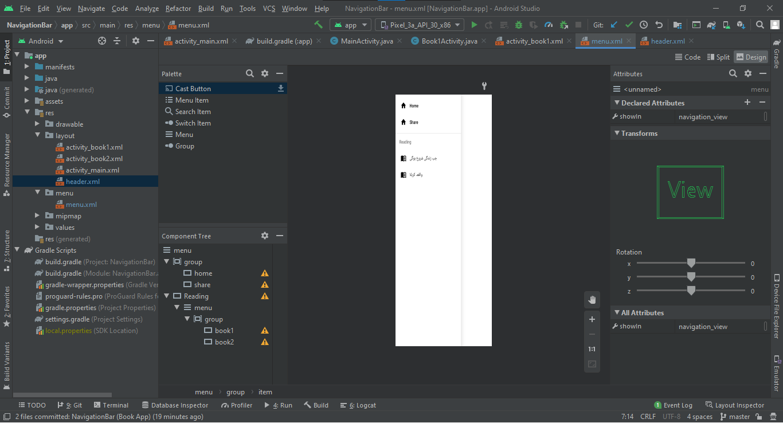

**Header.xml:**

Code

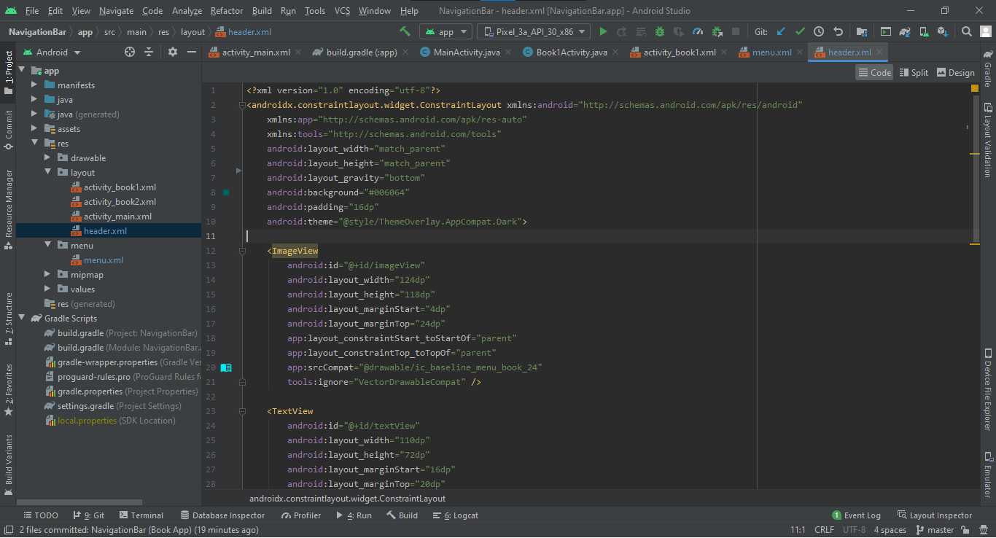

Design

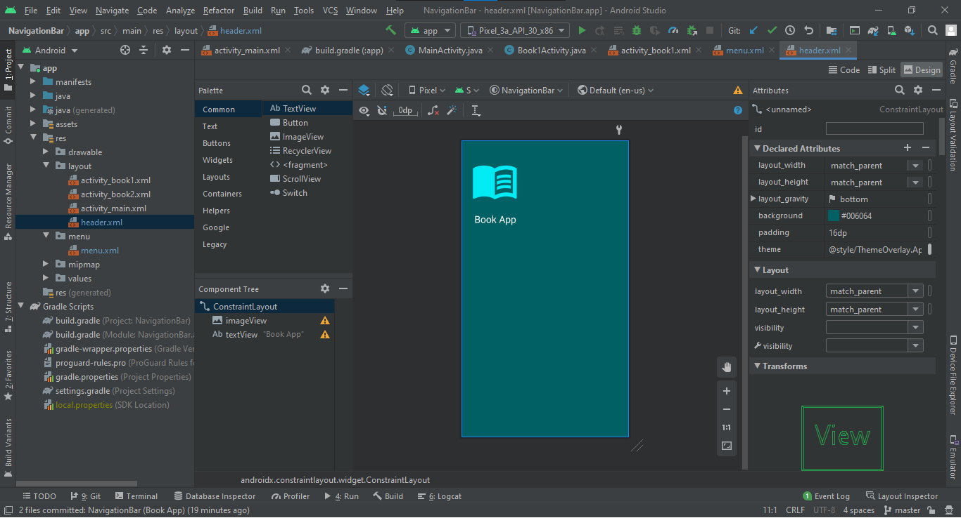

Code activity_main.xml as follows: 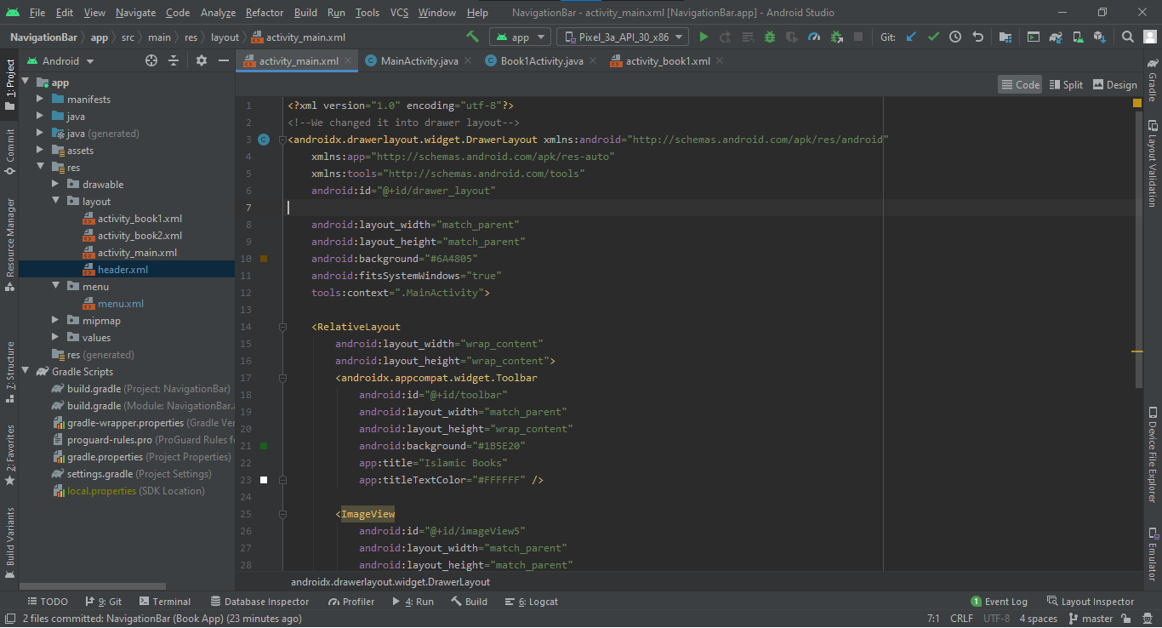 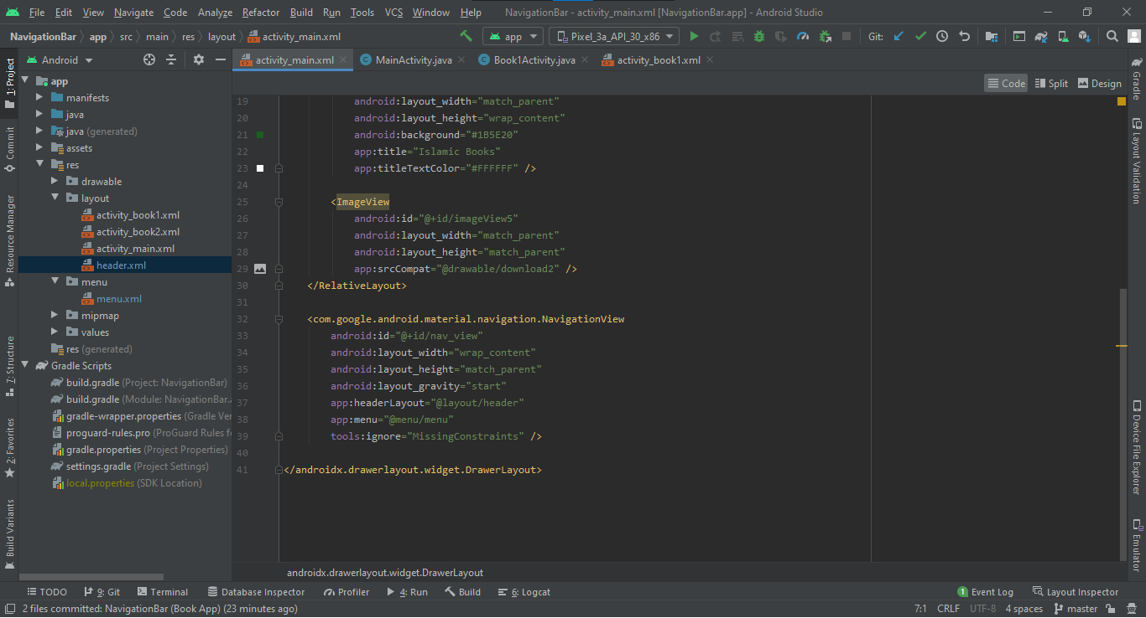

Code MainActivity.java as

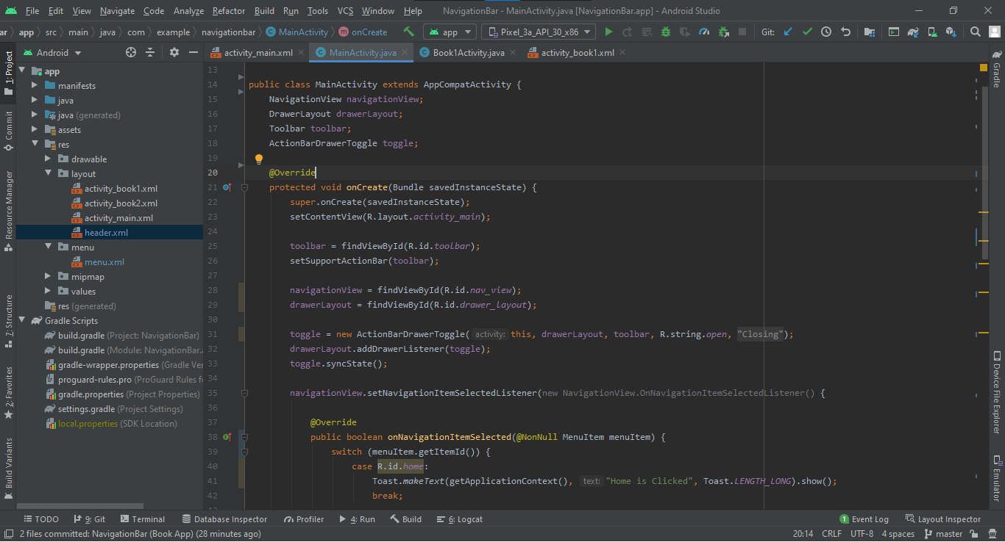 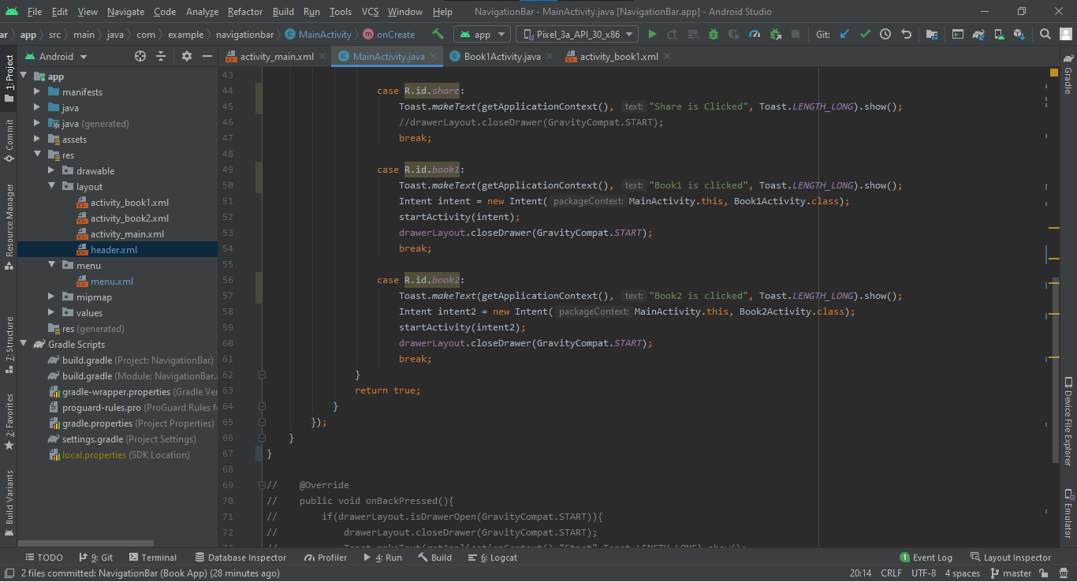

As I decided to make a book app, I wanted to add pdf books to an app.

So I learned how to add pdf file to an app. We have added a dependency earlier.

Book1Activity.java:

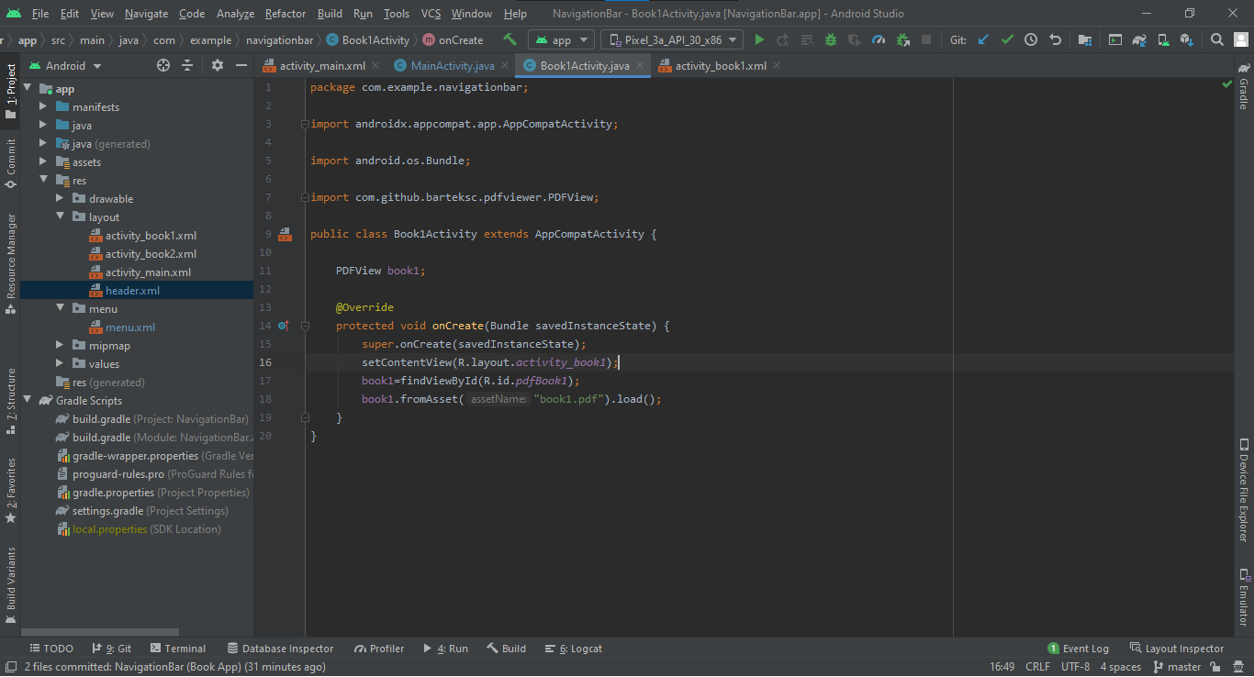

activity _book1.xml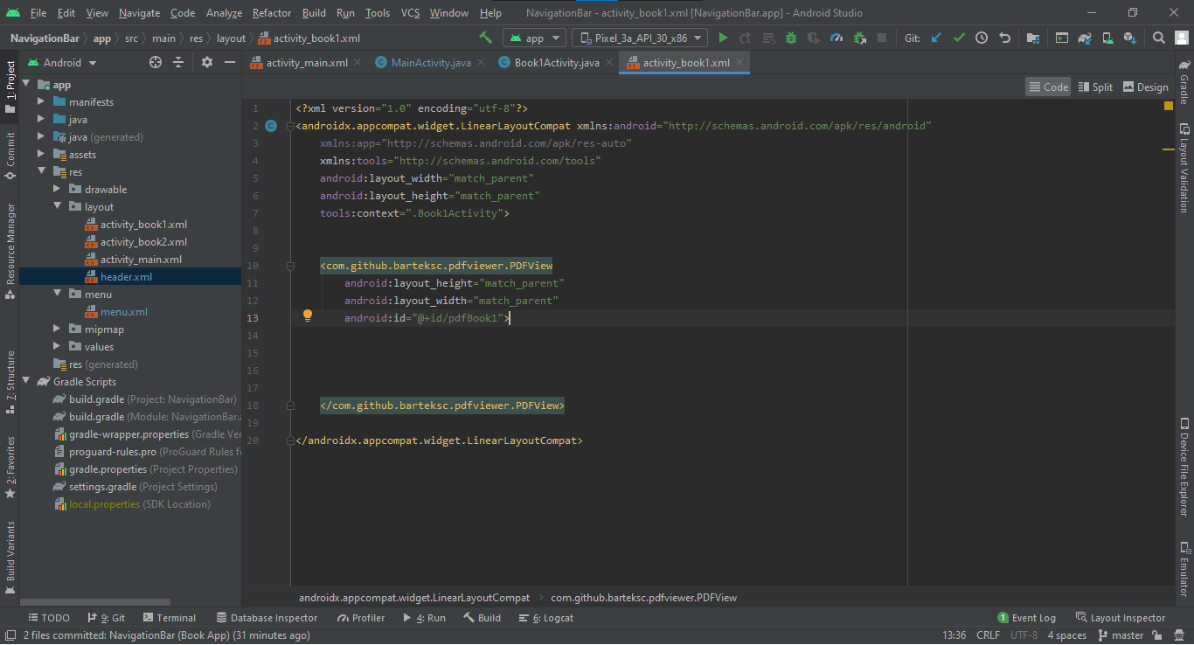

**Final Output:**

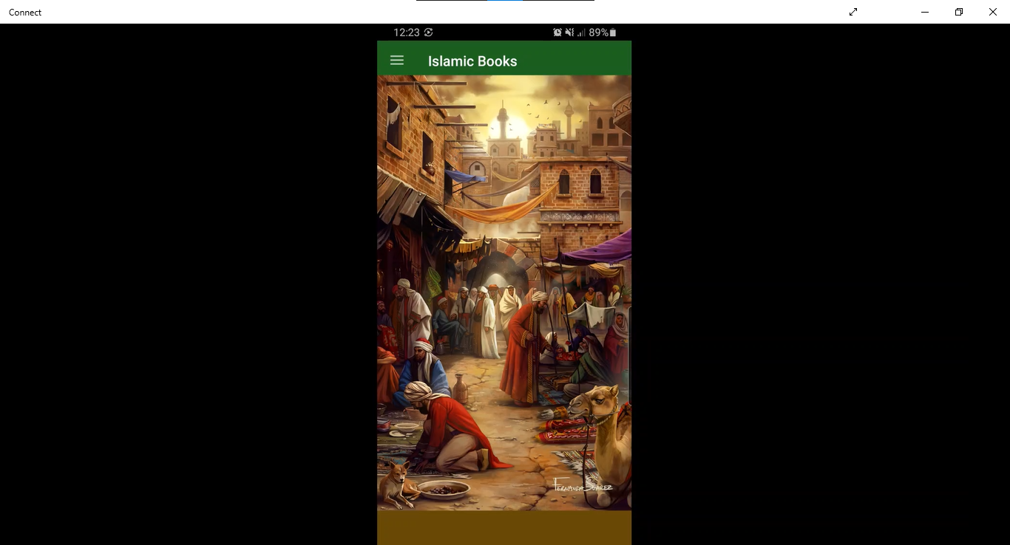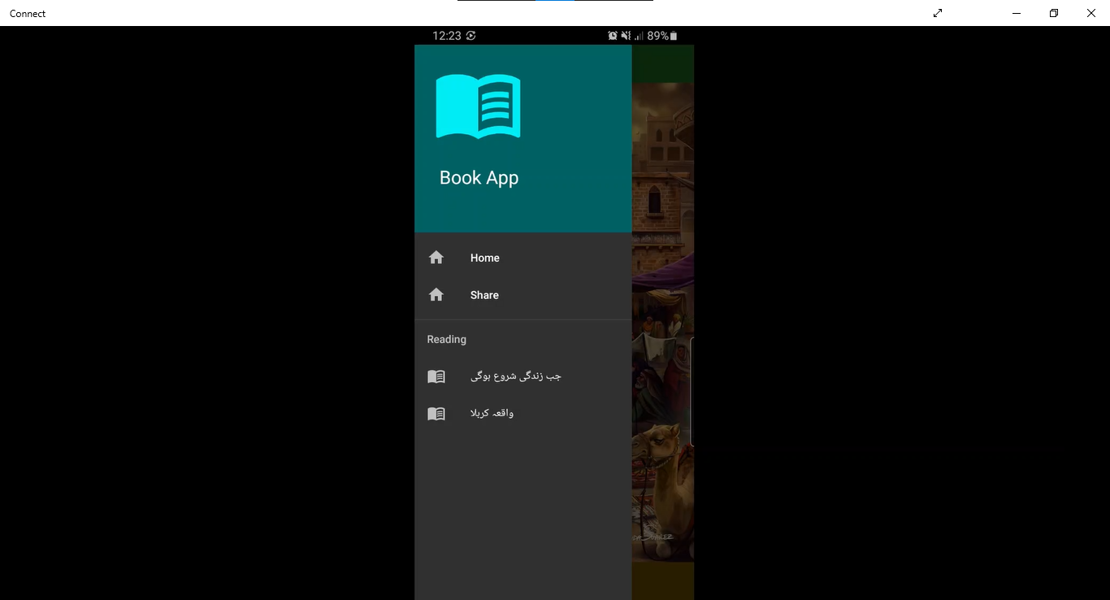 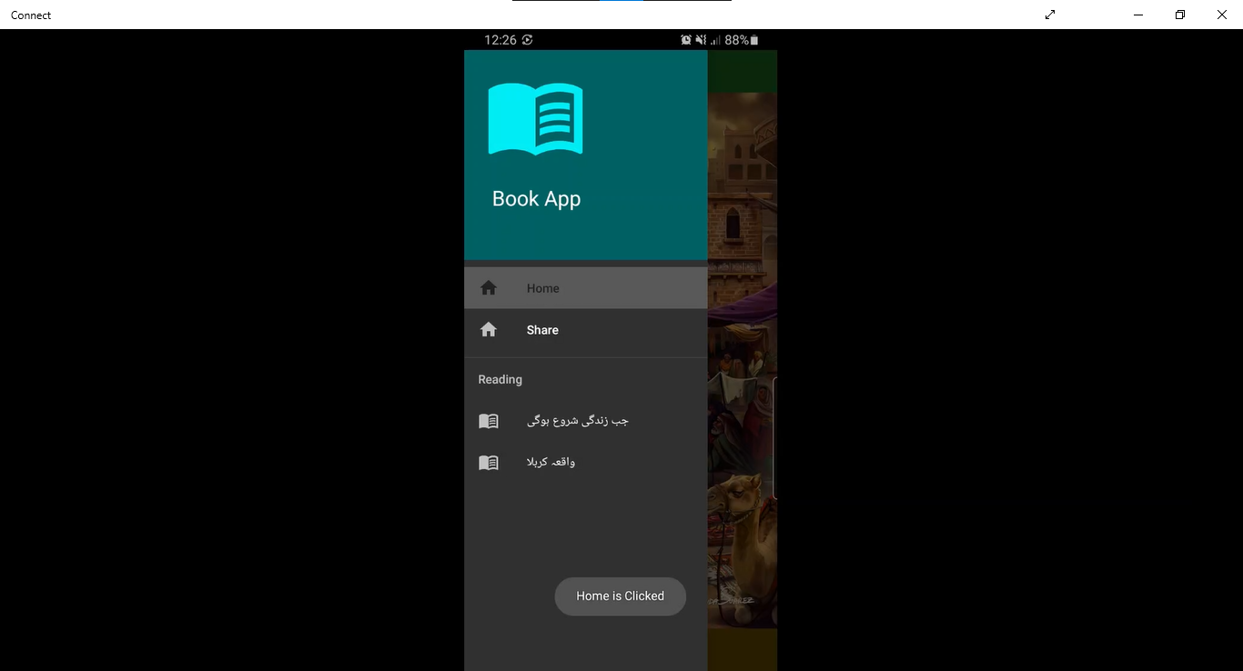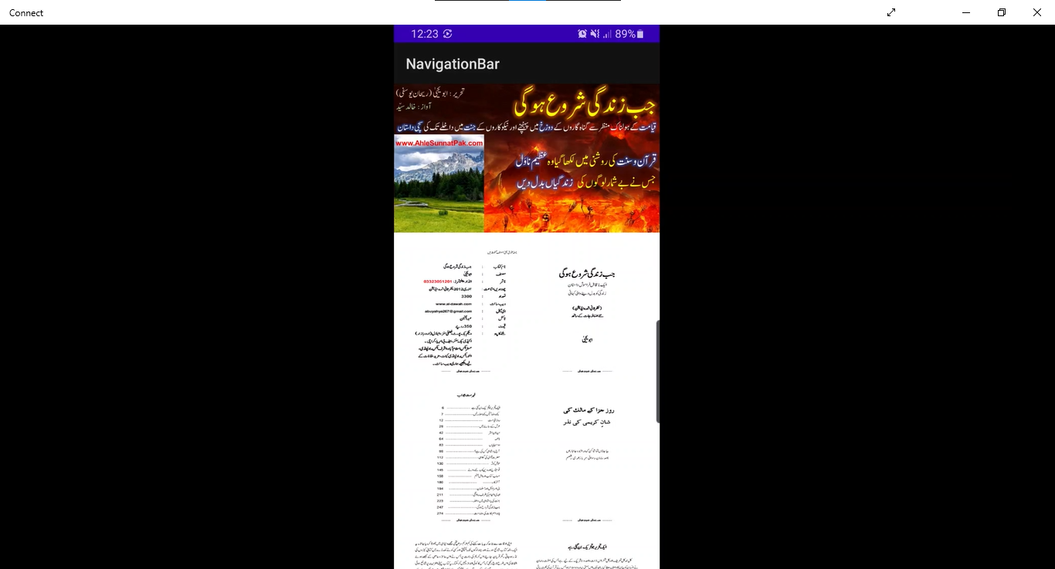

Find code at : <https://github.com/Saad-Ishtiaq/NavigationBar>

**Recycler View**

In Android, Recycler View is an advanced and flexible version of ListView and GridView. It is a container used for displaying large amount of data sets that can be scrolled very efficiently by maintaining a limited number of views.

We will code an app to understand Recycler View.

**Steps:**

1. Add recycler view in activity_main.xml.
2. Make an layout.xml file to design a pattern.

(In our case I made friends.xml, I also made friend class to make our implementation more easy)

1. Make RecyclerViewAdapter class:- basically this handles our data and add that data into our layout class.
2. Add some code in MainActivity.java to setup RecyclerViewAdapters.

**Activity_main.xml:**

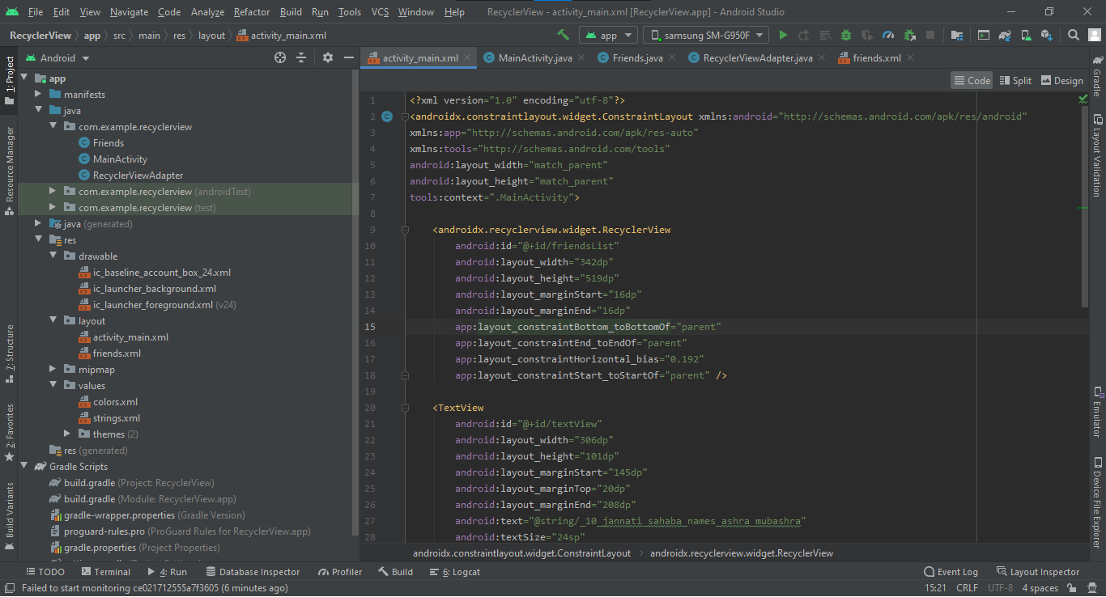

**Friend class:**

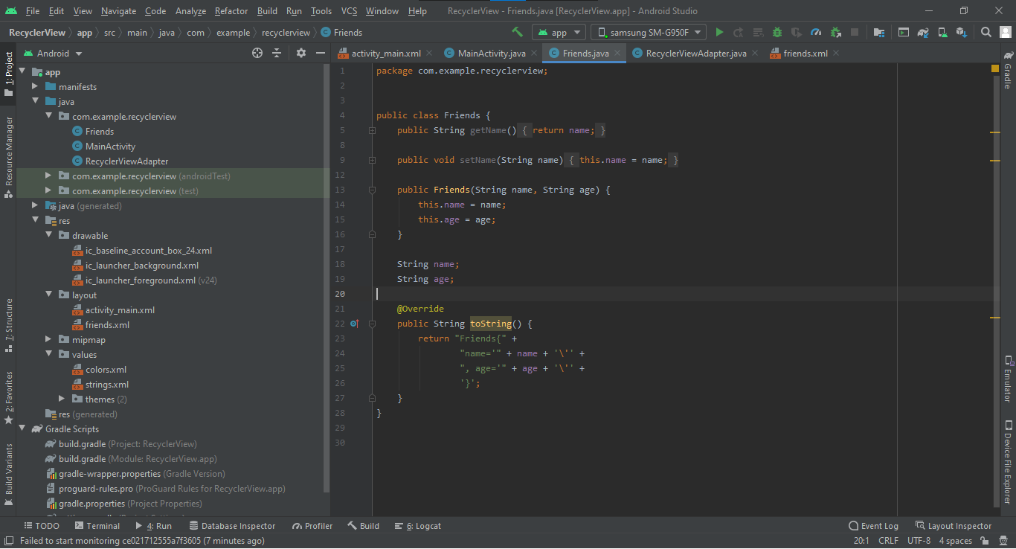

**Friends.xml: (Pattern)**

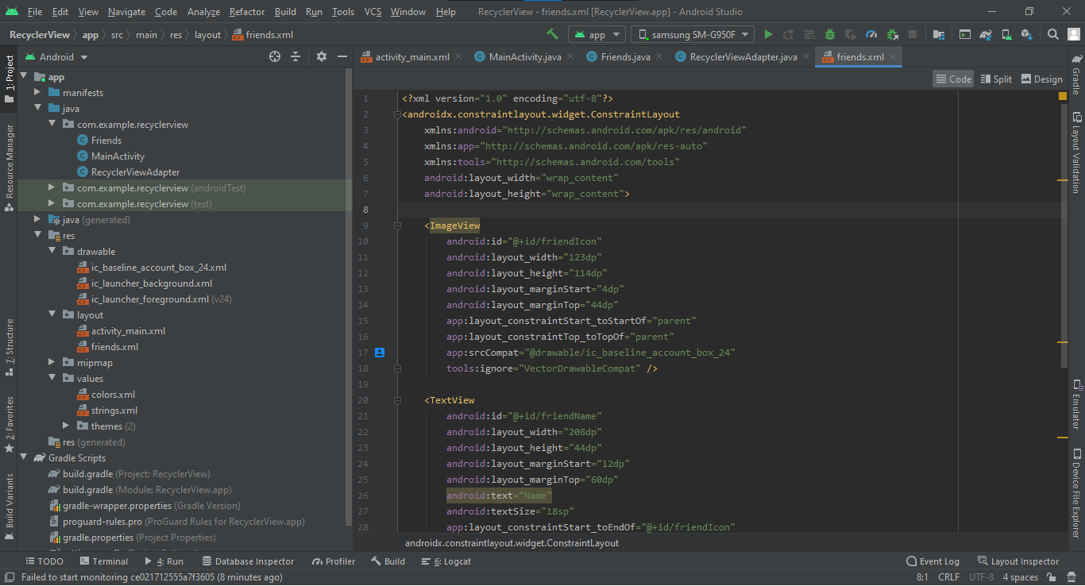

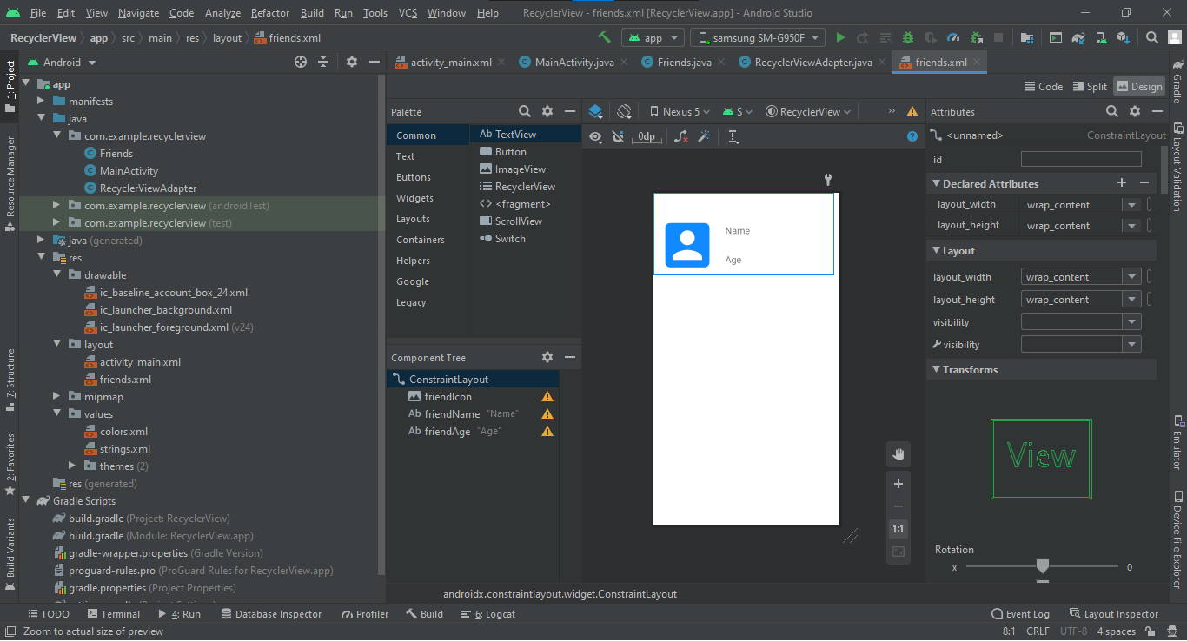

**RecyclerViewAdapter:**

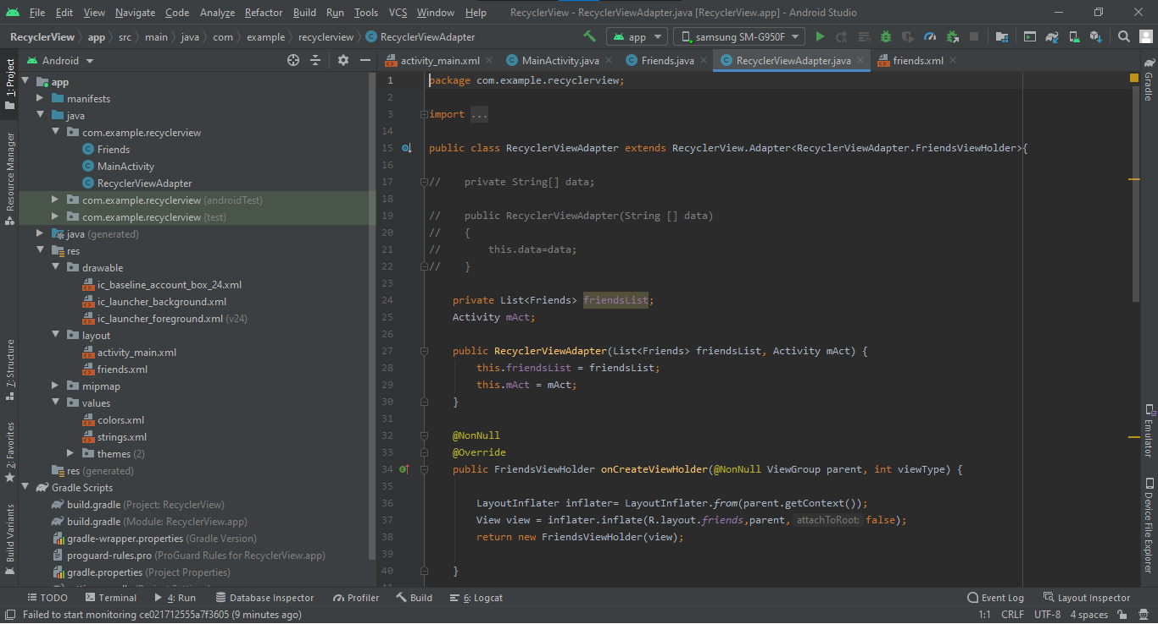 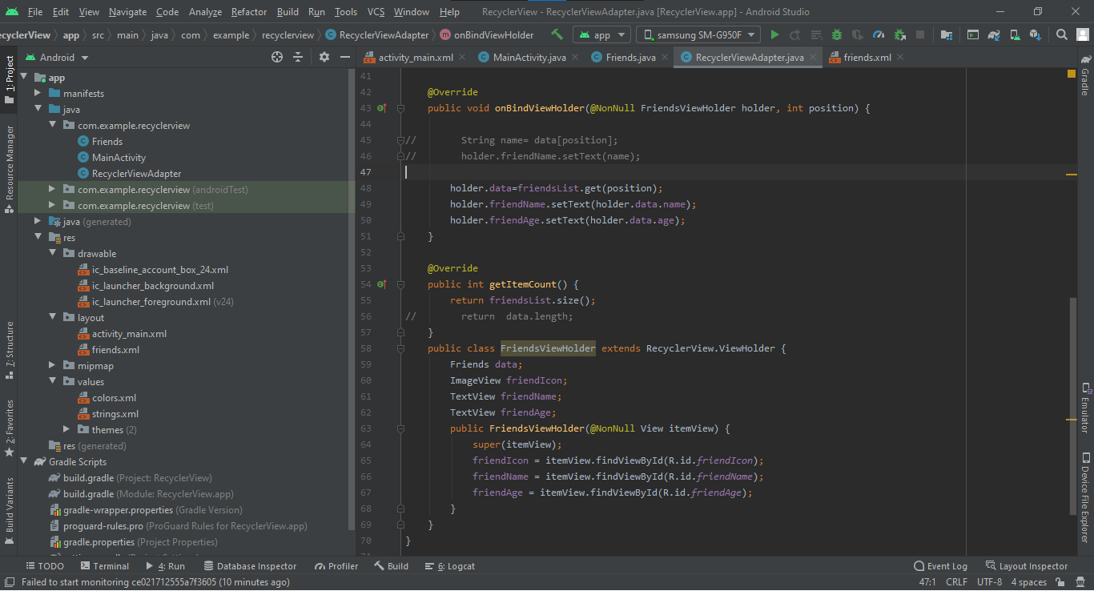

**MainActivity.java:**

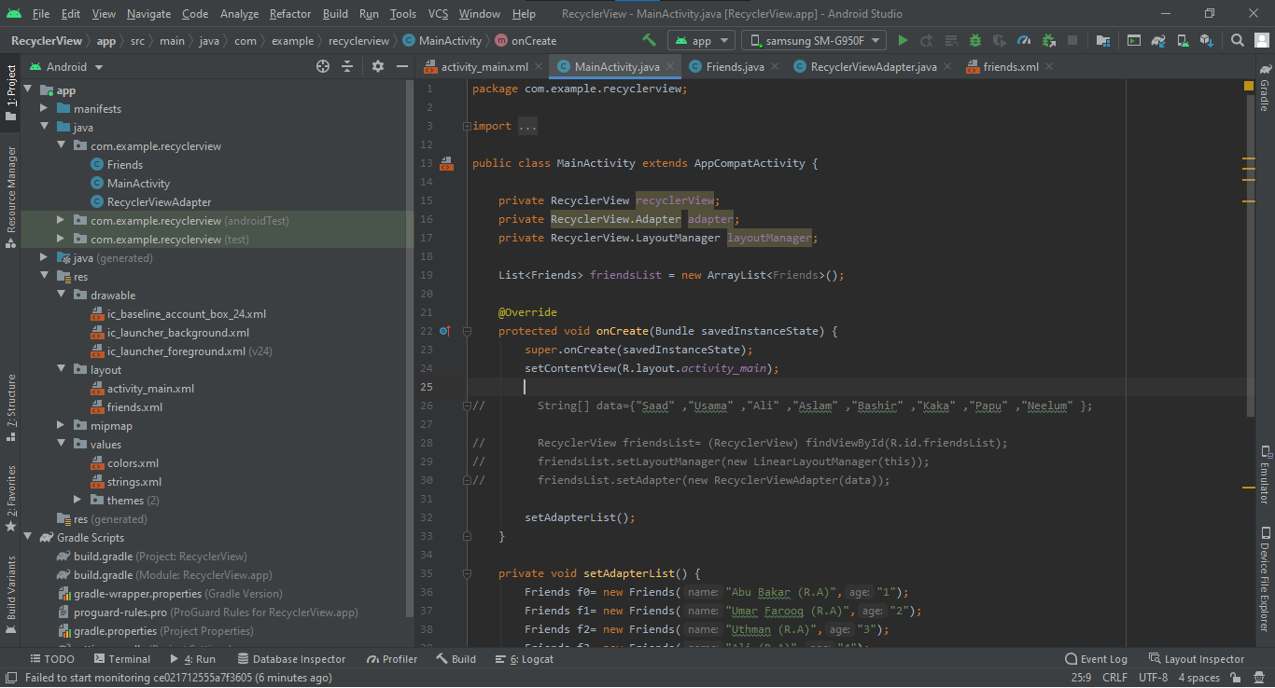

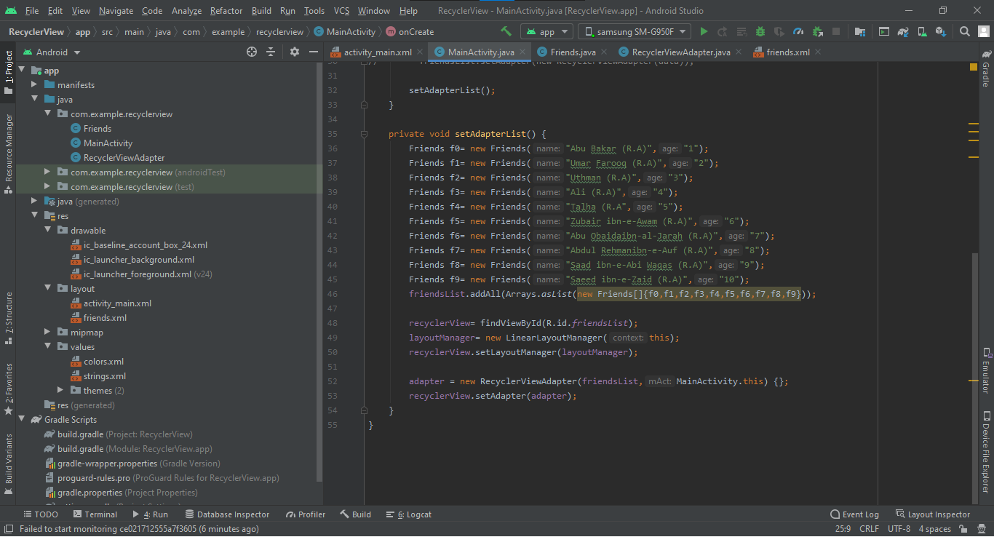

**Final Output:**

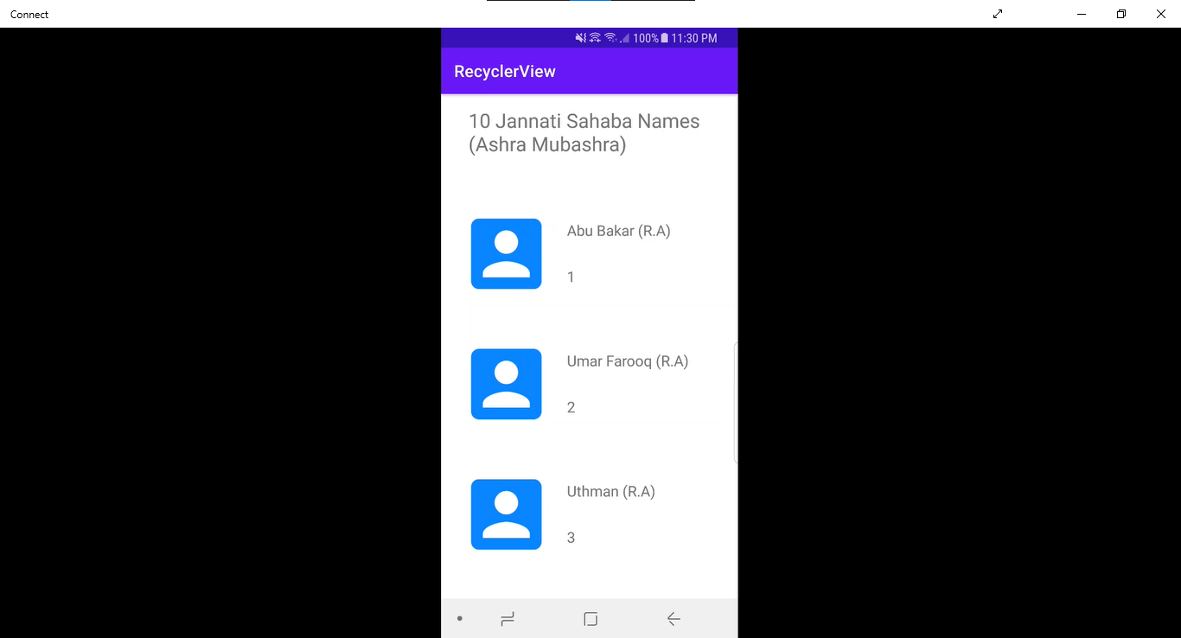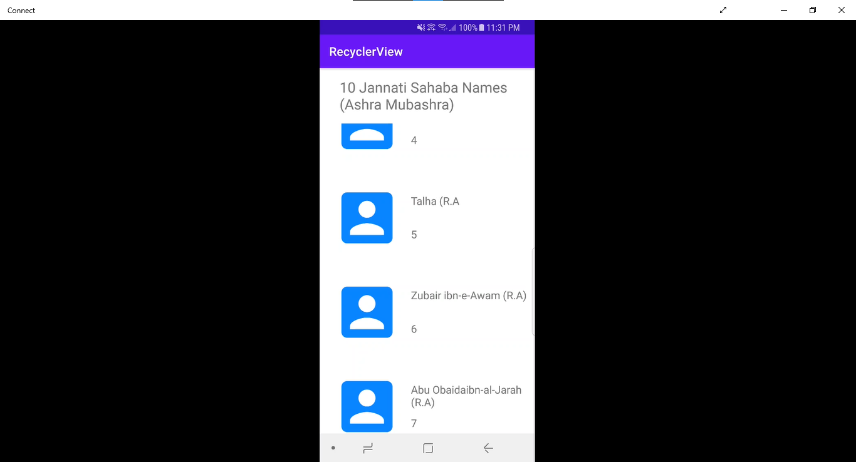

Find Code at: <https://github.com/Saad-Ishtiaq/MC-Work/tree/master/RecyclerView>

**Dialog**

Dialog box are interactive. AlertDialog 🡪 a subclass of Dialog that can display one, two or three buttons. If you only want to display a String in this dialog box, use the setMessage() method. If you want to display a more complex view, look up the FrameLayout called "custom" and add your view to it.

To code a dialog lets see an example of an app. I have made three buttons which opens three different dialog boxes i.e:

1. User-defined layout
2. List of Options
3. List of Options with check box.

Lets start by view activity_main.xml.

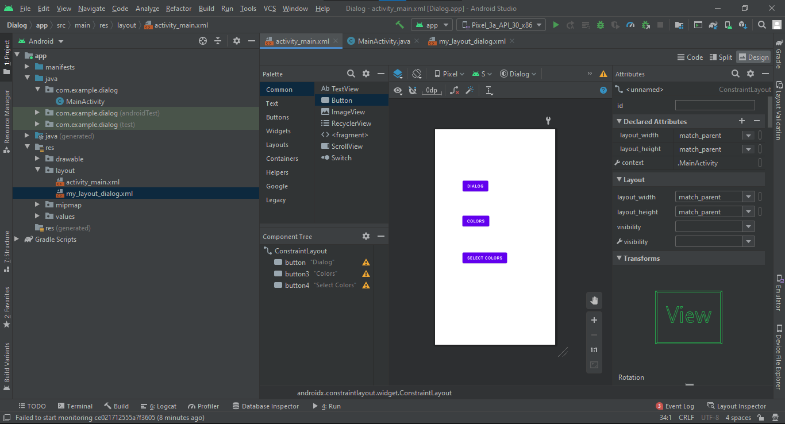

OnClick of each button there is a function defined at the back-end.

Lets start with first button. We want to show user defined layout so let us make a user defined layout first. I made “my_layout_dialog.xml”. I added a simple text view, a plain text view and a submit button.

View its implementation in picture below:

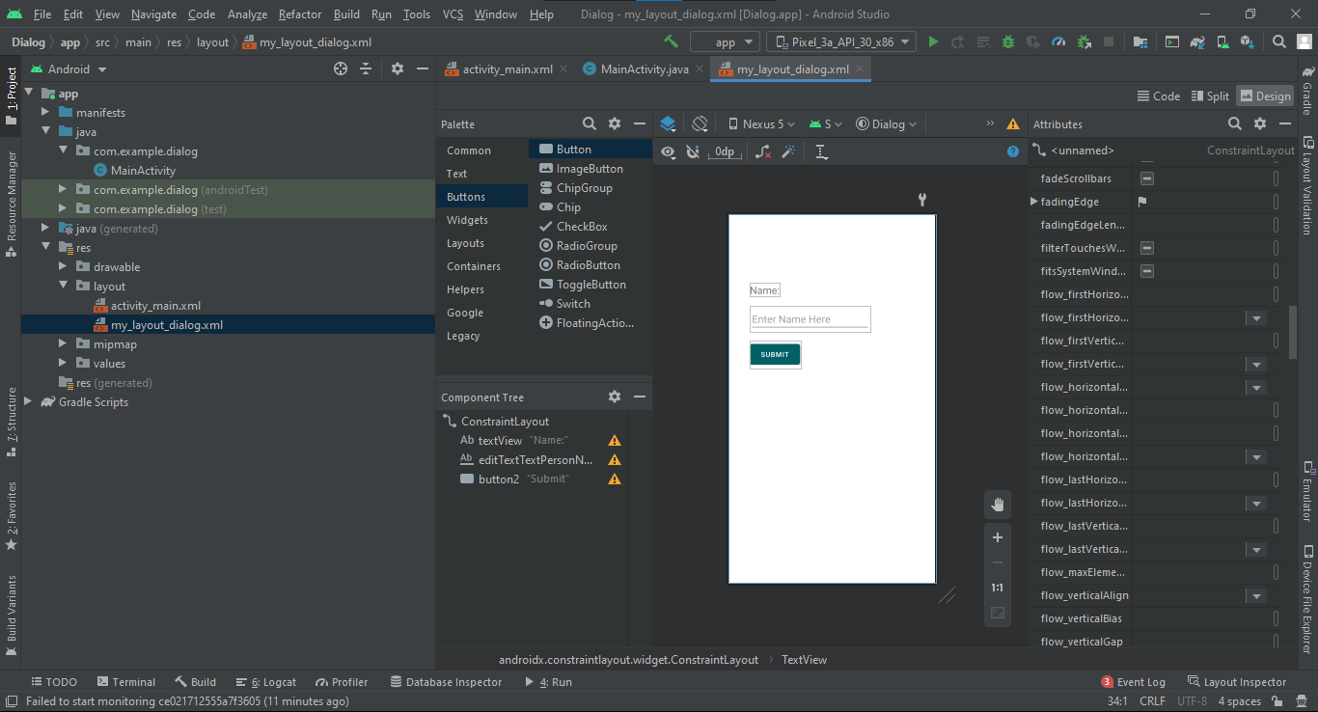

Now See the implementation on MainActivity.java. “showDialog” is the function which is called when first button is pressed.

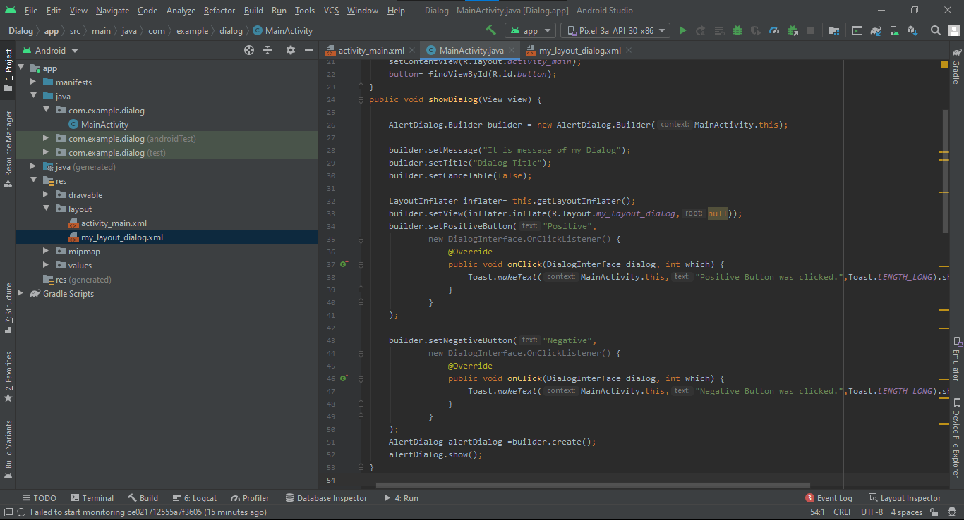

“colors” is the function which is called when second button is pressed.

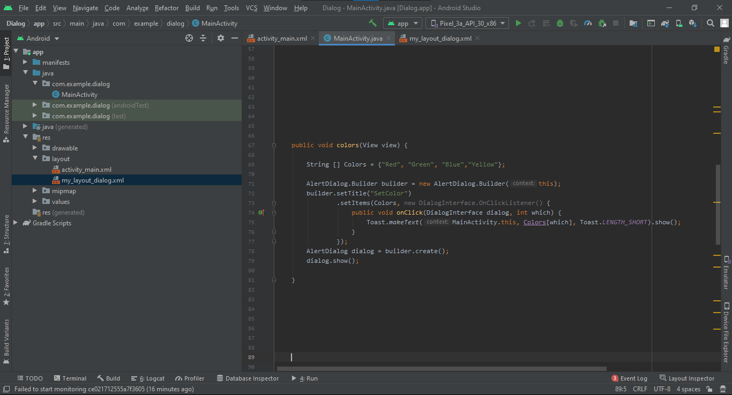

“selectcolors” is the function which is called when third button is pressed.

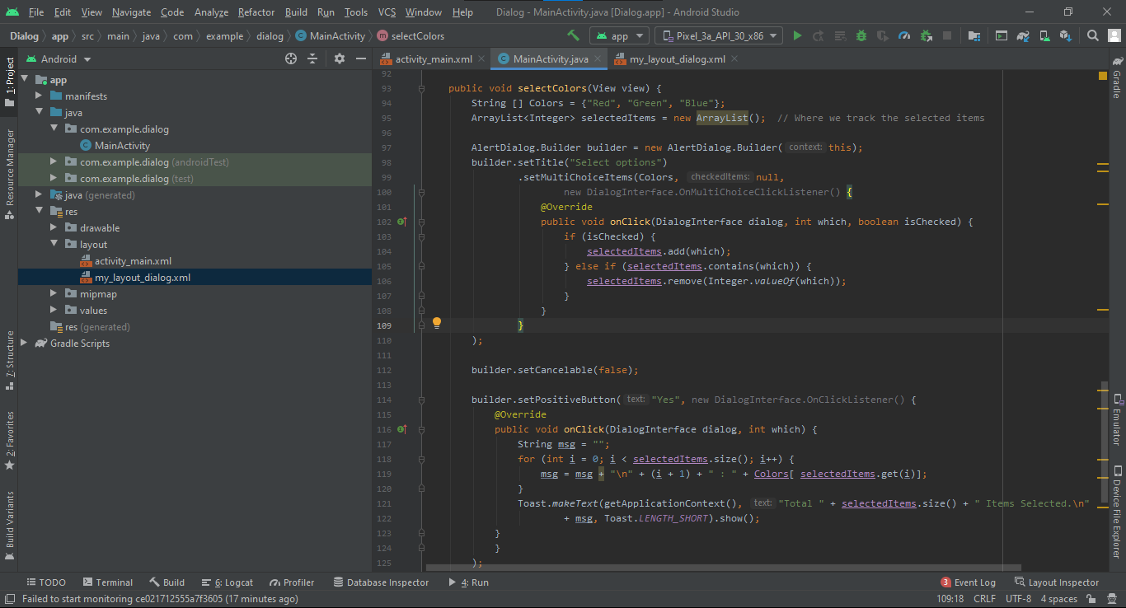

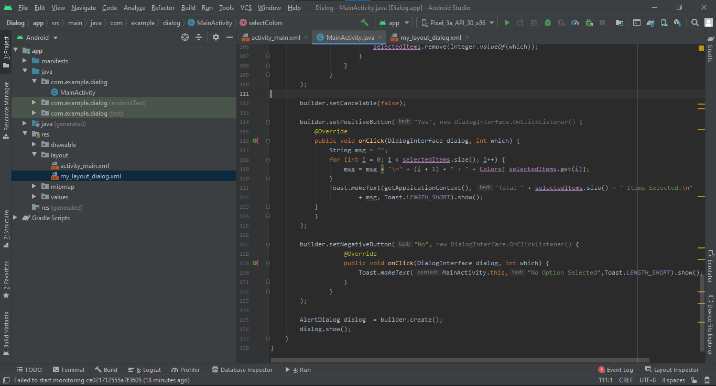

**Final Output:**

OnClick of first button

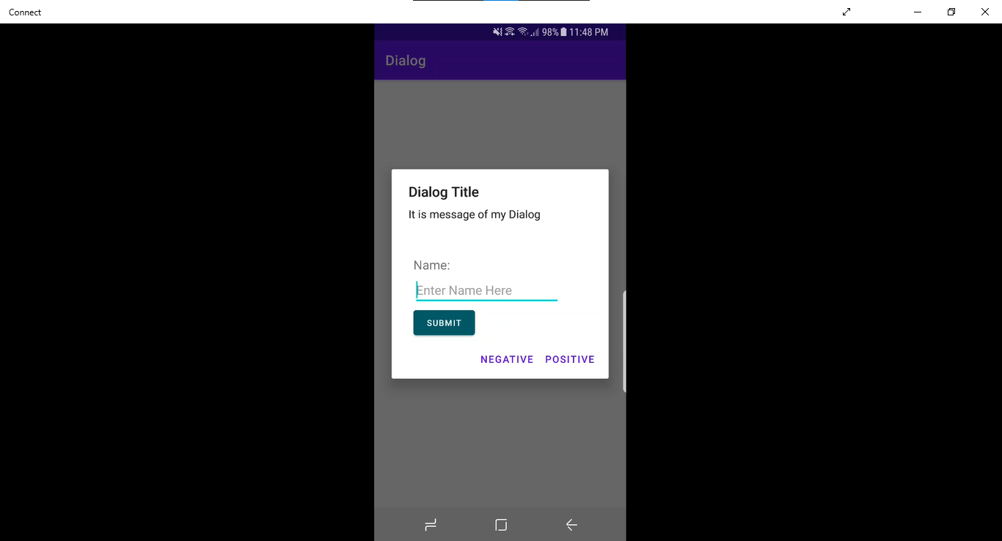

OnClick of Second button

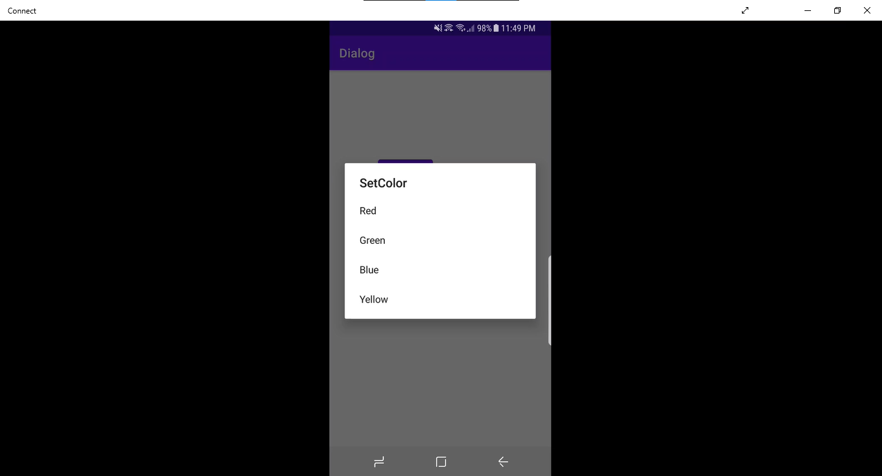

OnClick of Third button

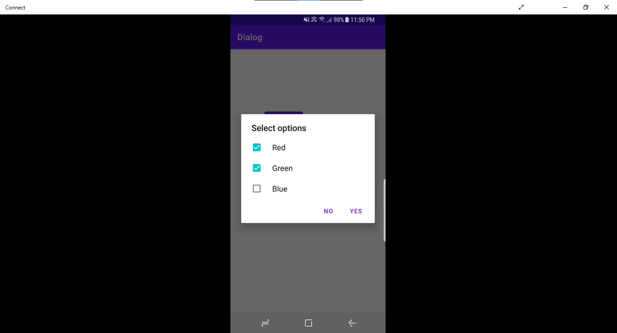

View Code at: <https://github.com/Saad-Ishtiaq/MC-Work/tree/master/Dialog>